1

1



**Financial Management**

**System**

**8**

User’s Manual

This document discusses the step

-

by

-

step procedures in properly using

and at the same time maximizing all the features of th

e

BizBox

Financial Management System

8

. Please read through the following

guidelines carefully and make sure that you understand them so that

you will be able to do this procedure properly

on the actual hospital

process

.

**BizBox**

**3**

**/**

**6/2012**

**Table of Contents**

INTRODUCTION 4

RECEIVABLES AND COLLECTIONS 5

Accounts Receivable 5

OPD Batch A/R Settlement 9

Batch A/R Posting Guarantor 11

Batch A/R Posting PhilHealth 12

Consolidated A/R Subsidiary Ledger 14

Hospital Bill Subsidiary Ledgers 15

Professional Fee Subsidiary Ledger 16

Others S/L 16

Patients Subsidiary Ledger 18

Cash Receipts 20

Cash Payment 20

Check Payment 22

Card Payment 24

Void OR 26

Re-Print Cash Receipt 26

Reapply Cash Receipt 28

Acknowledgement Receipts 29

Payer Credit Memos 30

PAYABLES AND DISBURSEMENTS 34

Patient Refunds 34

Accounts Payable Vouchers 37

Post Guaranteed PF Payables 42

Post Cash PF Payables 43

Post Readers Fee Payables 44

A/P Consolidated Subsidiary Ledger 45

Vendor Supplier Subsidiary Ledger 47

Consultants Subsidiary Ledger 49

Disbursement Vouchers 51

Check Voucher 51

Print Cheque 54

Print Voucher 55

Reapply Voucher 56

Amend Voucher 57

Releasing of Checks 58

Petty Cash Vouchers 59

Payee Debit Memos 63

Print Payee Debit Memos 65

Reapply Debit Memo 66

Debit Advice 67

Financial Accounting Script 68

Journal Vouchers 68

Journal Entries Inquiry 74

Audit Journal Entries 75

General Ledger 77

# Introduction

BizBox Inc. is a software company that focuses on providing a better hospital solution to the different Medical Facilities here in the Philippines and abroad. It has been existing for more than 15 years now and we continue to strive in developing a hospital system that will provide high-quality service to all the staff in the hospital and at the same time to the patients. After years of hard work, we have now come to the point of releasing the much anticipated system that is powerful, easy to use and full of exciting features.

Welcome to the BizBox Financial Management System! This is a useful tool intended to manage and organize the financial and accounting related transactions in the hospital. This system is interrelated and works hand in hand with the BizBox Hospital System 8 such that healthcare services will be given to all the patients and at the same time items and services will be readily available anytime. This video will discuss the different processes in the Financial Management System and guide you with everything you need to know to navigate the system.

We appreciate that you have chosen the Financial Management System 8 and in return we will make sure that you receive the necessary services that you deserve. To start with that, we present to you the following documents that will guide you in properly using the system. Please carefully read the following guidelines and procedures for you to be able to maximize the full potential of the system. This way, handling different records and doing different hospital related transactions will be easy, worry and stress free.

# Receivables and Collections

Let’s start on the transactions related to the different receivables, and collections on the hospital. We will also discuss the different processes on how to manage these kinds of records for a more systematic hospital flow, that will result into efficient and effective services. Here are the modules that are included on this group:

## Accounts Receivable

The Accounts Receivable is one of the accounting transactions, dealing with the billing of the customers, and patients. The **other** sources of A.R., are **auto generated** guaranteed transactions **from P.H.I.C., Company, or H.M.O., and credit card.** The following documents will show the processes on how to manage, and record the different account receivables in the hospital system.

1. To access this module, click Accounts Receivables in the main explorer, or from the Core Components menu pad.
2. To create a new A.R. record, just click the new command button.
3. On the search entity window, select the HMO or Guarantor on the list or you can use the search field above to easily find the record.

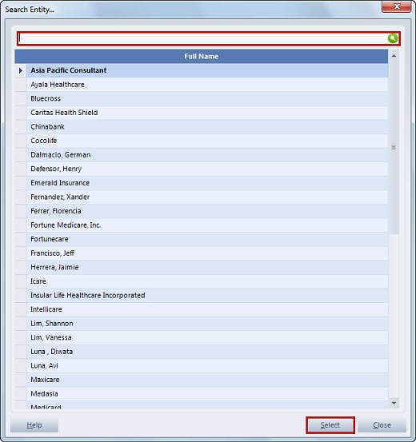

1. The Account Receivable details window will appear, supply the necessary information to the following fields, Document date, A.R. Category, Transaction Type, and grand amount.

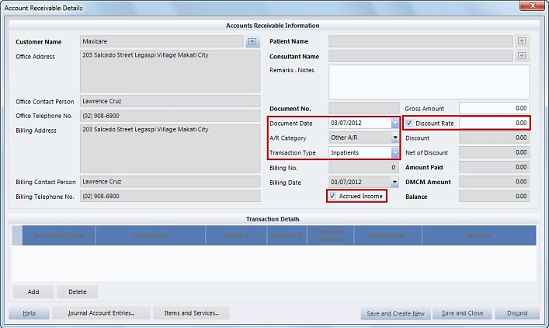

1. Enable the discount rate checkbox if the A.R. will be discounted, then indicate the discount rate on its field. You can also enable this checkbox Accrued Income and the other A/R Category field will be disabled and set to other A/R.
2. In addition, you can also input your Remarks, and Notes, if any on the space provided.
3. Take note, that if you selected Professional Fee, as an A.R. Category, you have an option to assign the Patient Name, and Consultant by clicking this button.

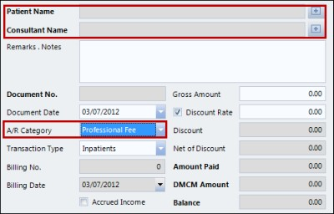

1. When you’re done, you can save and create new or save and close by selecting either of their buttons. On the other hand, you can click the close button to cancel the process.
2. After saving, you will notice that the newly created Account Receivable will now be added on the list, that means the procedure was successful.
3. You can check the correctness, and completeness of the newly created A.R., by using the view command button, or by clicking the Account Receivable details, under the Subcomponents. When you’re done viewing, click the Close button.
4. If there are inconsistencies that are detected, you can still modify them, by using the edit command button.
5. On the Account Receivable details window, update the necessary information on its field, then, click save and close when you’re done.

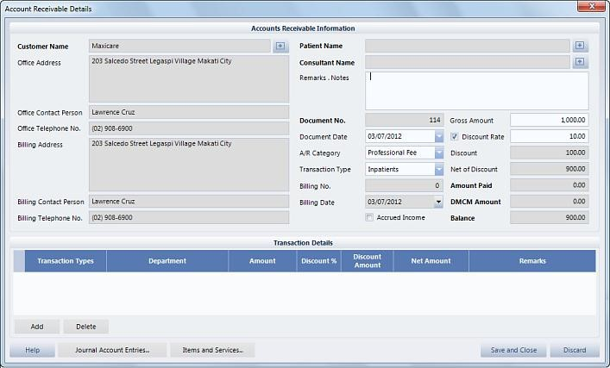

1. In addition, you can also remove an existing A.R. record, by clicking the delete command button. The Confirm Deletion window will appear informing you that this process will just mark the selected record as deleted but will not be erased physically from the database. Specify the reason for deletion on this field. After that, click Ok to continue, or Discard to cancel.

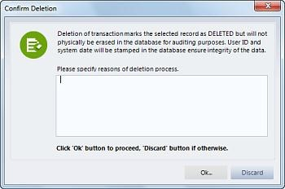

1. Input your user code and password on the password validation entry, then, click accept button.

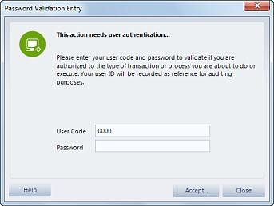

1. Take note the posted A.R’s cannot be deleted.
2. Before Posting the Accounts Receivable, make sure that the record is complete, and correct. To proceed with the posting, just click the post command button.

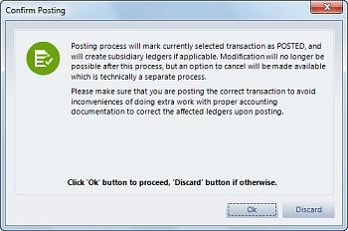

1. The confirm posting window will appear, informing you that this process will mark the selected A.R. as posted, and will create a subsidiary ledger if applicable. In addition, editing, and modifying the records will be disabled once the record is posted. To confirm the process, just click the Ok button. Input your user code and password on the password validation entry, then, click accept button.
2. You will notice that the A.R. will be tagged as posted represented, by a blue color that means the process was successful.
3. If for some reason, an incorrect detail on the A.R. was detected, and it is already posted, you can still Void, or cancel that A.R. using the Void command button.

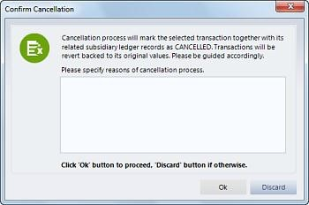

### OPD Batch A/R Settlement

This feature of the financial management system will enable you to process account receivable settlements for all the outpatients and emergency patients who has guarantors from the hospital system.

1. To start with that, select the Accounts Receivables module on the main explorer or from the core components menu pad.
2. Then click OPD Batch A.R. Settlement on the processing and queries under the sub explorer.
3. On the search entity window, highlight a guarantor on the list, then, click select button.

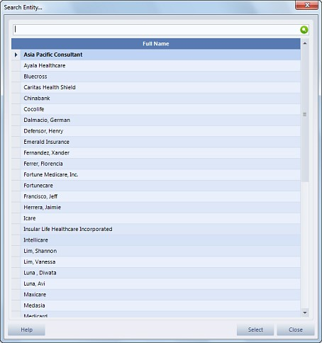

1. On the batch AR transfer details window, specify the department by enabling this checkbox then selecting from the drop down selection list. After that, click the apply filter preferences button for the ARs to appear. Click the plus sign to expand the record.

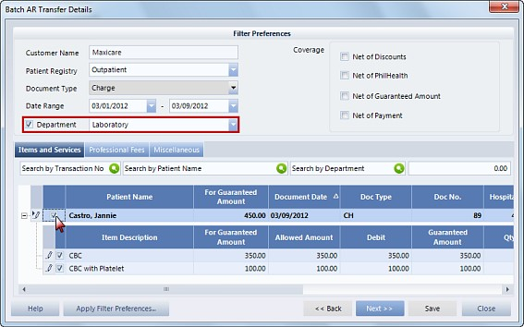

1. On the items and services tab Put a checkmark on the outpatient record and the items included on the transaction will also be checked. You can also choose to include or not to include a specific item by zeroing out its for guaranteed amount on its column, that is.
2. Same goes with the professional fees and in miscellaneous tabs, you can also settle O.P.D. batch A.R. for these specific fees of the patient.
3. After that, click next button.
4. Double check if the entered information, and other details before selecting the save button.

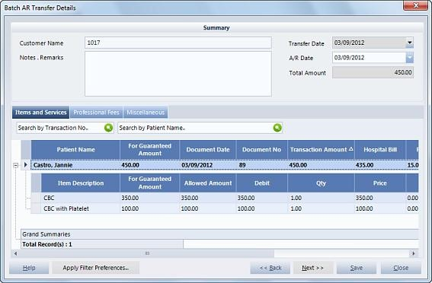

1. On the password validation entry, enter your user code and password, then, click accept button.
2. You will now notice that the new A.R. settlement will be added on the list of A.R’s.

### Batch A/R Posting Guarantor

We will now perform the batch A.R. posting from different guarantors involved in the patients’ hospital transactions.

1. On the accounts receivable module, click the Batch A/R Posting Guarantors under the Sub explorer.
2. The Post to Accounts Receivable Subsidiary window will appear. Use the filter preferences above, for you to view the different A.R’s to be selected under a specific guarantor.

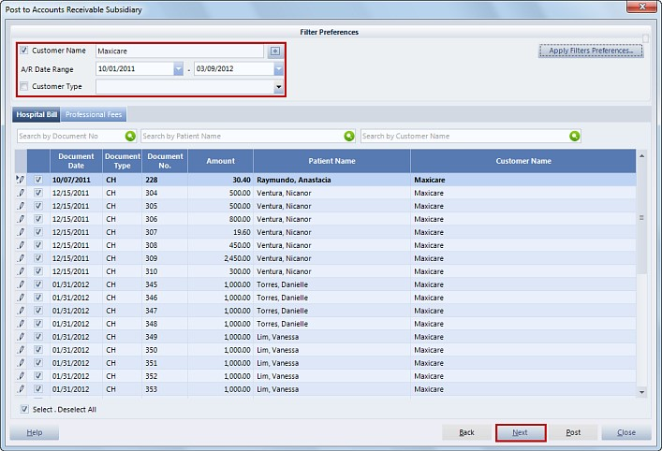

1. You will notice that under these tabs, namely patient receivable and professional fees, you should select the account receivables on the list by enabling the checkboxes. You can use the search fields to easily find the ARs. Same with the other tab, select the A.R., by enabling the checkbox.
2. When you’re done with the selection, click the next button. You will see that the selected A/Rs will remain on the list. Specify the A/R date on this field then input your notes or remarks here if necessary. After that, click the post button.

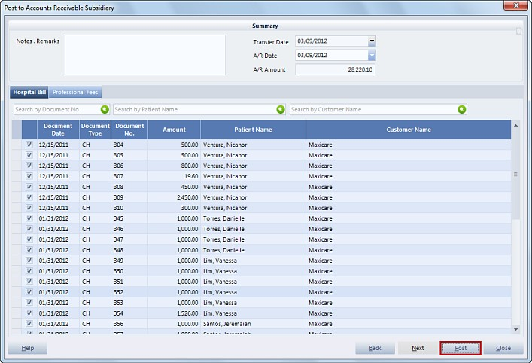

1. On the password validation entry, enter your user code and password, then, click accept button.

### Batch A/R Posting PhilHealth

This process involves posting accounts receivable subsidiary Philhealth. This feature is dependent on the philhealth information system, so before starting to use this, make sure that you are also familiar with the PHIC system. Here’s a quick process on the proper management of these information on the Financial Management System.

1. To start with this process, click the batch A/R posting PhilHealth under the sub explorer.
2. The Post to Accounts receivables Subsidiary PhilHealth window will appear, use the filter options above, to view the A/Rs to be selected.

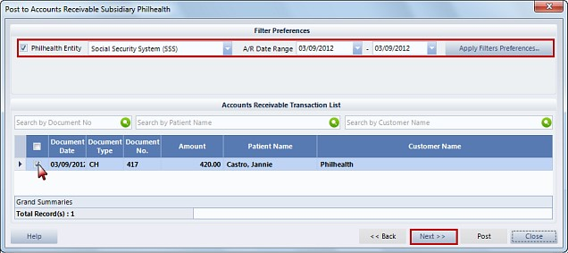

1. You should then select the account receivables on the list, by enabling their checkboxes.
2. You can also use these search fields to easily find and select the A.R’s, if they are too many.
3. When you’re done with the selection, click the next button. You will see that the selected A.R’s will remain on the list.

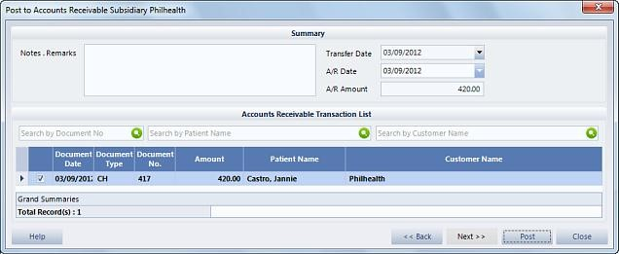

1. Specify the A.R. date on this field then input your notes or remarks here if necessary. After that, click the post button.
2. On the password validation entry, enter your user code and password then click accept button.

### Consolidated A/R Subsidiary Ledger

This feature of the financial management system will let you view all the consolidated subsidiary ledgers that composed of the A.R’s from hospital bills, professional fees, and others. Here’s a quick process on how to access these information:

1. On the Accounts Receivables module click the Consolidated A/R Subsidiary Ledger button on the sub explorer. The search entity window will appear, highlight a guarantor on the list then click select button.
2. On the Accounts Receivable Subsidiary Ledger you can use the filter preferences to show the Consolidated A.R's.
3. You will then notice that a list of Receivables together with the payments, and adjustments applicable to the selected guarantors will appear. You can click this button to view the cash receipt details for Official Receipts, payer debit credit memo details for different adjustments made to the Accounts Receivable, or account receivable details.

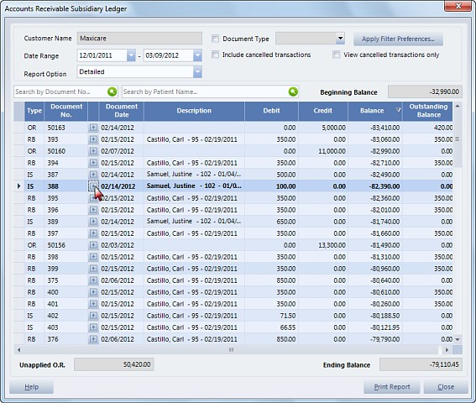

1. Using this feature of the financial management system, you can ensure the correctness and completeness of the account receivables. When you’re done with viewing, click the close button and go back to the account receivables module main window.

### Hospital Bill Subsidiary Ledgers

We can also access the hospital bill subsidiary ledger using the Financial Management System. This feature will show the A.R’s, that are from the hospital bills of the different patients.

1. To start with the process, click the hospital bill subsidiary ledger, under the sub explorer. The search entity window will appear, choose the guarantor on the list, then, click the select button.
2. On the Accounts Receivable Subsidiary Ledger, you can use the filter preferences above, to show the hospital bill A.R’s.
3. You will then notice that a list of Receivables together with the payments, and adjustments applicable to the selected guarantors will appear; you can click this button to view the cash receipt details for Official Receipts, payer debit credit memo details for different adjustments made to the Accounts Receivable, or account receivable details.

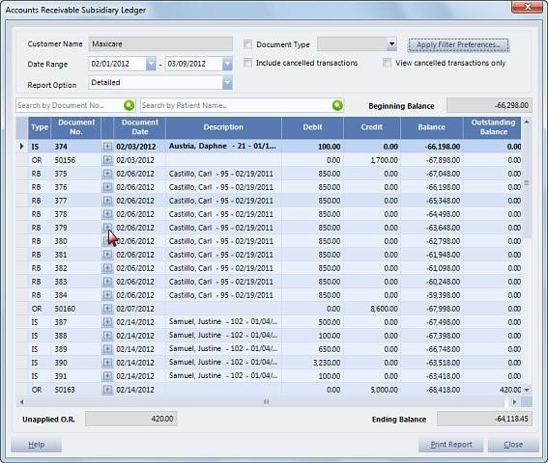

1. Using this feature of the financial management system, you can ensure the correctness and completeness of the hospital bills account receivables. When you’re done with viewing, click the close button and go back to the account receivables module main window.

### Professional Fee Subsidiary Ledger

1. Aside from the hospital bills, you can also access the Professional fee subsidiary. This feature will show the receivables from the professional fees of the different patients. On the Accounts Receivable, click the Professional Fee Subsidiary ledger, under the sub explorer. The search entity window will appear, choose the guarantor on the list, then, click the Select button.
2. On the Accounts Receivable Subsidiary Ledger, you can use the filter preferences to show the professional fee A.R’s.
3. You will then notice a list of Receivables together with the payments, and adjustments applicable to the selected guarantors will appear. You can click this button to view the cash receipt details for Official Receipts, payer debit credit memo details for different adjustments made to the Accounts Receivable, or account receivable details.

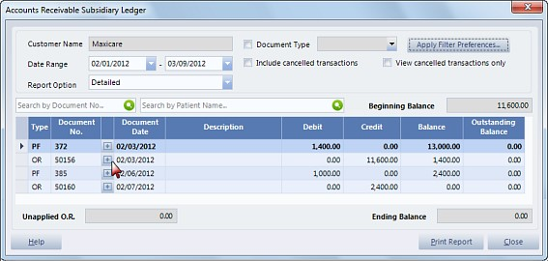

1. Using this feature of the financial management system, you can ensure the correctness, and completeness of the professional fees account receivables.
2. When you’re done with viewing, click the close button and go back to the account receivables module main window.

### Others S/L

Lastly, you can also access the other subsidiary ledgers. This feature will show the accruals, and other receivables, not related to patients.

1. To start with the process, click the Others subsidiary ledger, under the Sub explorer. The search entity window will appear, choose the guarantor on the list, then, click the select button.
2. On the Accounts Receivable Subsidiary Ledger, you can use the filter preferences above, to show the other Receivables.
3. You will then notice that a list of Receivables together with the payments, and adjustments applicable to the selected guarantors will appear. You can click this button to view the cash receipt details for Official Receipts, payer debit credit memo details for different adjustments made to the Accounts Receivable, or account receivable details.

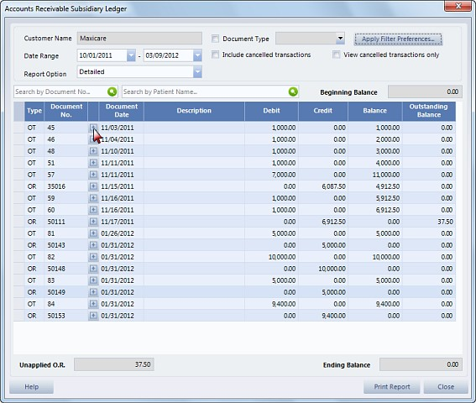

1. Using this feature of the financial management system, you can ensure the correctness and completeness of the other account receivables. When you’re done with viewing, click the close button and go back to the account receivables module main window.

### Patients Subsidiary Ledger

Using this feature of the F.M.S., you can print the different accounts receivable of the different patients. Here’s a quick process on that:

1. On the Accounts receivables module, select patients subsidiary ledger on the processing and queries, under the sub explorer.
2. The accounts receivable patient window will appear, use the filter preferences above, for the different A.R’s to be listed, and to modify the reports to be printed. After that, select the print reports button.

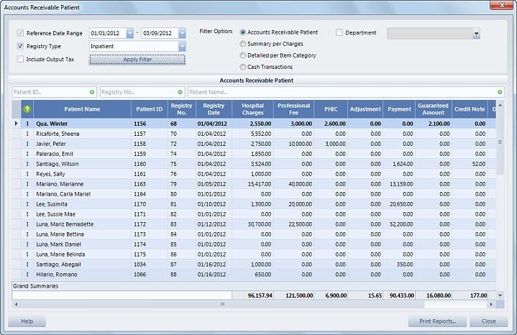

1. A preview of the report will appear, review all the details, and information before choosing to print. After that, you can print the reports, by clicking this icon.

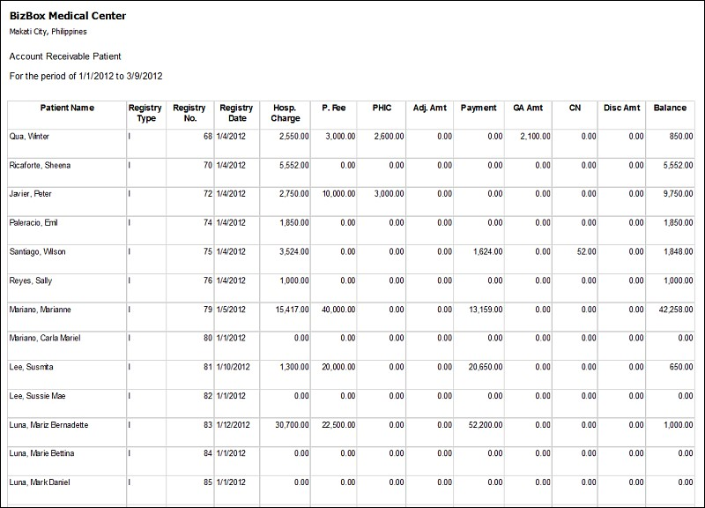

1. After printing, close the preview window.
2. When you’re done with all those processes, click the close button, and return to the Cash Receipts main window.

## Cash Receipts

This time, we will be discussing the different transactions that can be performed using the cash receipts module on the Financial Management system. The following processes are somewhat the same as the cash receipts module on the hospital system, so if you already know that, this would be easy for you to learn.

### Cash Payment

Cash payment is the most common mode of transaction in the hospital. This video will present the process of transacting thru cash using the Financial Management system.

1. On the FMS main window, click the Cash Receipts on the main explorer, or from the core components menu pad.

To begin with the Cash payment transaction, just click the new command button.

1. On the Search Entity window, highlight a guarantor on the list, then, click the select button.
2. On the Cash Receipts details window, input the following information: receipt number, and date. Take note that, you have the option to input the number of the receipt, but there is also a setup for the system to auto generate the receipt number.

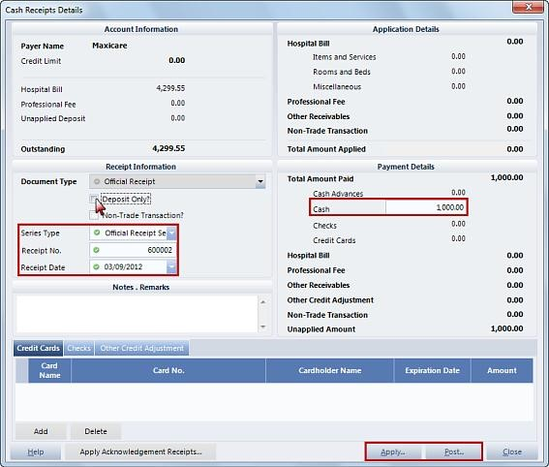

1. You can enable the deposit only checkbox, if the guarantor chose to deposit a payment even if it doesn’t have any transactions in the hospital yet.
2. On the other hand, if the payment is not a deposit, and the guarantor decides to pay his bills for the patients’ hospital’s items and services used, just disable the checkbox.
3. You will notice that if you do this, the Apply button enables, that means that if the payment is a deposit, you do not need to apply to the items and services because the guarantor is not yet active in the hospital transactions.
4. You can also input your Notes and remarks on the space provided, but this is just optional.
5. On the payment details, enter the value of the payment on the Cash field. Base this value from the outstanding field on the upper left side of this window. After that, click the apply button.
6. On the Application of Receipts to receivables window, select from the list the applicable outstanding account receivables by enabling the checkboxes.

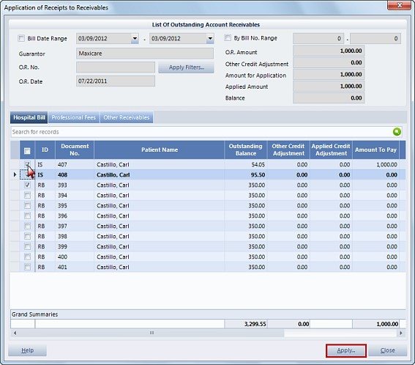

1. You can also indicate the amount to pay on this column, remember that the amount should be equal to the cash payment that was entered earlier.
2. You can also do this if there are other receivables and other credit adjustment by clicking these tabs. After that, click Apply button.
3. You will notice that there are now entries on the applicationdetails.
4. When all those procedures are done, click post button. Enter your User code and password on the password validation entry, then, click Accept.
5. The print cash receipt window will appear, enter the amount received, then, you can preview the receipt first, before printing. Check the correctness and completeness of the receipt, then, click the printer icon above or you can also click close, and do this process later. After all that, click the close button.
6. You will notice that the applied amount, or the payment is now posted on the Cash Receipts list.
7. You can view the new record, by clicking the view command button, or selecting the cash receipt details on the sub components. Review if the details are complete, and correct. When you’re done viewing, click the close button.

### Check Payment

Another type of payment can also be accepted, and that is thru check. Here’s a quick process on that:

1. Given that you are now on the Cash Receipts module, select New command button.
2. On the Search Entity window, highlight a guarantor on the list, then, click the select button.
3. On the Cash Receipts details window, input the following information: Receipt number, and date.

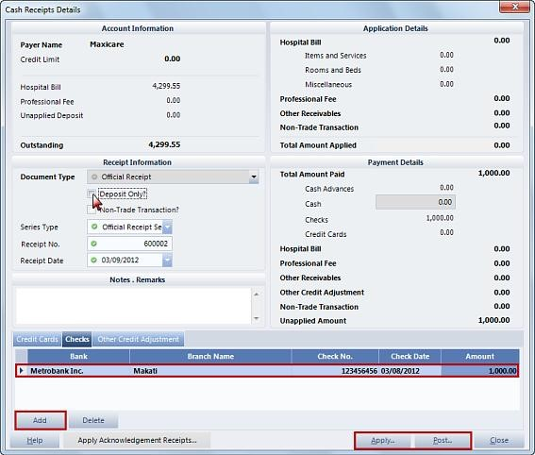

1. You can enable the deposit only checkbox, if the guarantor chose to deposit a payment, even if it doesn’t have any transactions in the hospital yet. On the other hand, if the payment is not a deposit, and the guarantor decides to pay his bills for the patients’ hospital’s items and services used, just disable the checkbox.
2. You will notice that if you do this, the Apply button enables, that means that if the payment is a deposit, you do not need to apply to the items and services because the guarantor is not yet active in the hospital transactions.
3. You can also input your Notes and remarks on the space provided, but this is just optional.
4. Since this is a check payment, select the checks tab, then, click Add button.
5. Supply the necessary information on the table: the bank, branch name, check number, check date. If for example, the patient issued a Postdated Check, you should enter the date when the check will have a corresponding amount to be applied on the receipt, while, if the check is good as cash, just input the date when the payment is made. After that, key in the Amount.
6. You can add multiple checks if the guarantor has a lot of them by clicking the add button again. If ever you have committed some errors, you can delete the entry, then, click yes on the pop-up window.
7. When you’re done, click Apply button.
8. On the Application of Receipts to receivables window, select from the list the applicable outstanding account receivables, by clicking the plus button and enabling the checkboxes.

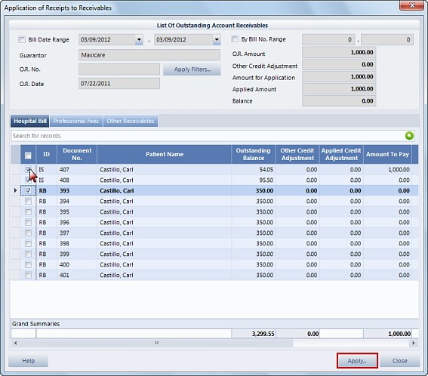

1. You can also indicate the amount to pay on this column, remember that the amount should not be more than the check payment that was entered earlier. Do the same, if there are other receivables, and other credit adjustment, by clicking these tabs. After that, click Apply button.
2. Going back to the previous window, you will notice that there are now entries on the application details.
3. When all those procedures are done, click post button.
4. Enter your User code and password on the password validation entry, then, click Accept.
5. On the print cash receipt window, enter the amount received. Then, you can preview the receipt first before printing, or you can also click close, and print the receipt. When you’re done with all that, click the close button.
6. You will notice that the applied amount or the payment is now posted on the Cash Receipts list.
7. You can view the new record by clicking the view command button of selecting the cash receipt details on the sub components. Review if the details are complete and correct and if you’re done click the close button.

### Card Payment

In addition to cash, and check payment there is also the credit card mode of payment. This video will discuss the process on that, here it is:

1. To record a payment using a credit card, you need to click the new command button on the cash receipts module.
2. On the Search Entity window, highlight a guarantor on the list, then, click the select button.
3. The cash Receipt details window will appear, containing the different details of the account of the guarantor that represents the different patients in the hospital. Specify the receipt number, and date on their respective fields.

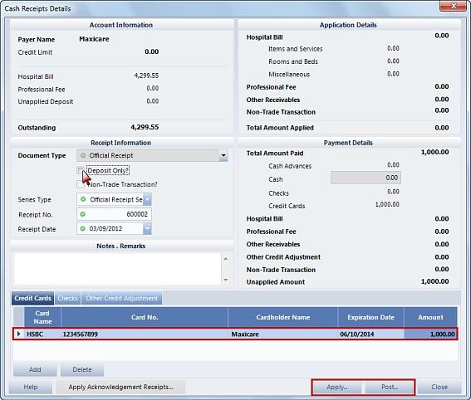

1. The deposit only checkbox will define the type of payment of the guarantor. If it has no transaction with the hospital and it is willing to deposit its money, then, enable this checkbox. On the other hand, if the guarantor already has assigned patients in the hospital with transactions, this should be a non-deposit payment so please disable this checkbox. This process will enable the Apply button, since you have to apply the payment to the different patient’s transactions with the hospital.
2. After that, select Credit Cards tab, then, click Add button. Key in the necessary information under the following columns: Card Name, Card Number, Cardholder Name, Expiration Date, and Amount.
3. You can also add another entry if the guarantor wishes to pay using another card by clicking the add button. You can also use the delete button if you committed some errors in inputting information.
4. After that, click Apply. On the Application of Receipts to receivables window, select from the list the applicable outstanding account receivables. Put checkmarks on the selected entries under the selected A.R. You can also indicate the amount to apply on this column. Remember that the amount should not be more than the cash payment that was entered earlier. You can also do this if there are other receivables, and other credit adjustment by clicking these tabs. After that, click Apply button.

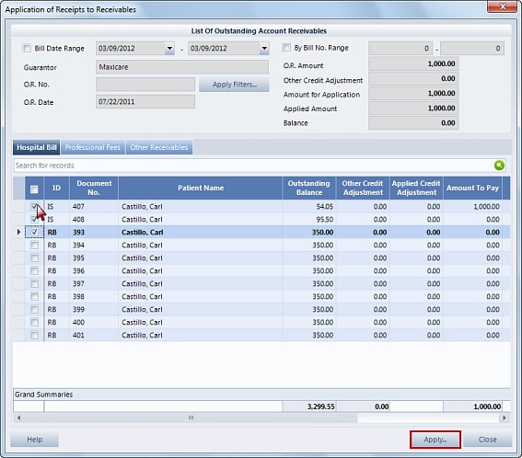

1. Going back to the previous window, you will notice that there are now entries on the application details.
2. When all those procedures are done, click post. Enter your User code and password on the password validation entry, then, click Accept.
3. The print cash receipt window will appear, you can preview the receipt first before printing, then, after checking the details of the document, you can now click the printer icon above, or you can also choose close, and click print on the previous window. After all that, click the Close button.
4. You will notice that the applied amount or the payment is now posted on the Cash Receipts list.
5. You can view the new record by clicking the view command button or by selecting the cash receipt details on the sub components. Review if the details are complete and correct and if you’re done click the close button.

### Void OR

1. If there are errors that were committed applying the payment of the guarantor and posting, we can still cancel the official receipt using the Void command button. Here’s a quick process on that:
2. On the Cash Receipts module, select an Official receipt on the list then click Void command button.
3. A system alert will appear, you can enable this checkbox to convert the O.R. number to negative, if not, just leave it unchecked. Click Go to continue with the process, or Discard to cancel.

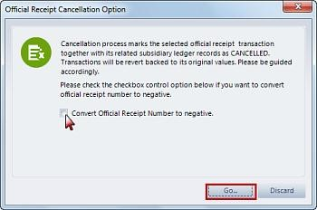

1. On the password validation entry, enter your user code and password then click accept button.
2. You will notice that the selected O.R. will have a Voided status represented by a red color that means that the process was successful.

### Re-Print Cash Receipt

1. You can also reprint the cash receipts of different guarantors. Here’s a quick process on that:
2. Using the Cash Receipts module, select a receipt on the list, then, click Re-Print Cash Receipt on the Sub Explorer.
3. The Print Cash Receipt window will appear, containing some of the details of the receipt.

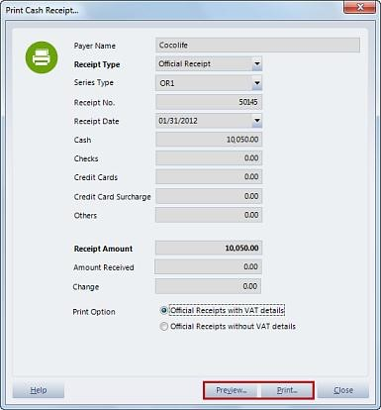

1. Before proceeding with printing, make sure that all the data are correct, by viewing the receipt first, using the preview button. Check if the details on the cash receipt are complete and correct. After that, you can click print button or you can also choose close and click print on the previous window.

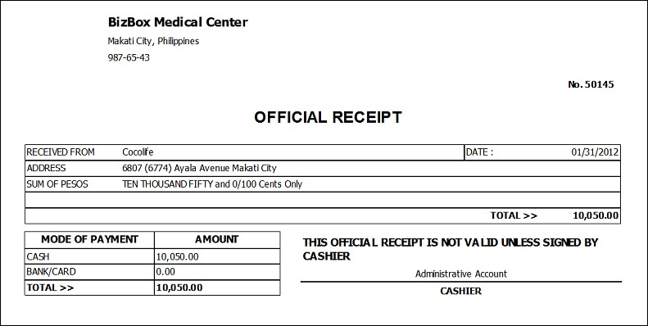

1. When you’re done printing, just click the Close button.

### Reapply Cash Receipt

1. Reapplying receipts is used to process cash receipts that are unapplied or partially applied. Here’s a quick process on that:
2. On the Cash Receipts module, select a partially applied receipt with a sky blue color, or you can also select a cash receipt that is not yet applied, which is represented by a gray color. After that, click Reapply Receipt on the Sub Explorer.
3. The Application of Receipts to receivables window will appear. Select receivables using the patient receivables tab, then, click this button to select entries, and entering the amount to pay on this column. If there are other receivables, and other credit adjustments, use their respective tabs to select them.

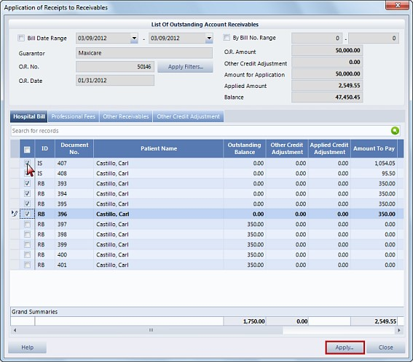

1. After that, click apply button.
2. You will now notice that the status of the cash receipt will be fully applied represented by a blue color, which means that the reapplication of the receipt was successful.

### Acknowledgement Receipts

1. These are the provisionary receipts of patients that can be managed using the financial management system. Here’s a quick process in managing these records:
2. On the Cash Receipts module, select acknowledgement receipts on the sub explorer under the sub components.
3. On the Acknowledgement receipts window, you can use these filter options to access the different receipts. You can also add an entry by clicking the add button then select a patient on the patient registration selection window.

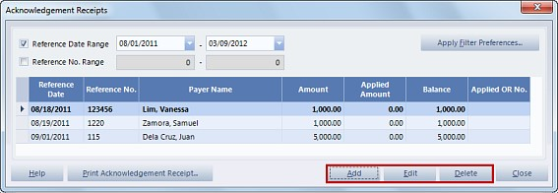

1. On the add acknowledgement receipt window, enter the appropriate reference number, amount and the reference date on their fields. You can also enter your remarks if needed.

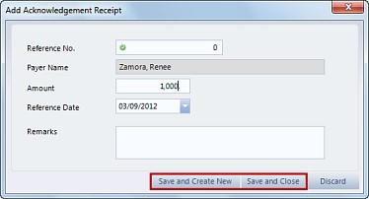

1. You can save and create another acknowledgement receipt or you can save and close by clicking their respective buttons.
2. You will notice that the new record will be added on the list, you can still edit it by clicking this button. Update the information on its field. When you’re done editing, click the Save and close button. If the receipt is no longer needed, you can remove it, using the delete button.
3. After that, you can choose to print the acknowledgement receipt by clicking this button.
4. Make sure that all the information is correct, then, click the printer icon above.
5. Take note that the application of the acknowledgement receipts can only be done on the Cash Receipts module of the Hospital Information System 8.
6. When you’re done with all those processes, click the close button, and return to the cash receipts module main window.

## Payer Credit Memos

There are also the payer credit memos that are part of the receivables, and collectibles from the different guarantors. This Payer Credit Memo is applicable for the credit adjustment to be made in the Accounts Receivable from customers, or guarantors. Here are the different processes that will help you manage the records, and perform transactions that are related to the credit memos.

1. To start, on the F.M.S. main window, click the Payer credit memos on the main explorer, or from the Core Components menu pad. In creating a new payer credit memo, you should just click the new command button.
2. On the Search entity window, you can make use of the search field above, to easily find the guarantor, then, click the select button.
3. The Payer debit Credit Memo details window will appear, containing the lists of account receivables from where you should select, by enabling the checkboxes.

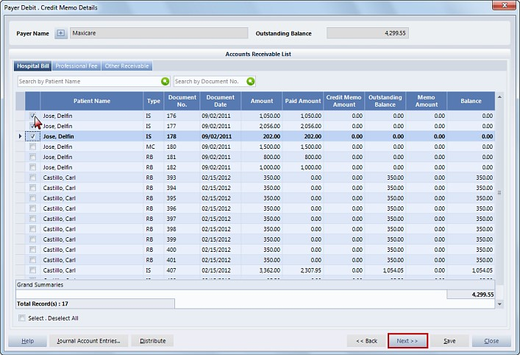

1. In addition you can also select A.R’s from the other tab which is the other receivable. After the selection, input the memo amount on this column, the value of this should be equal to the balance amount.
2. After that, click the next button. Input the following information: transaction type, credit memo number, and date then key in your remarks, and notes if necessary.

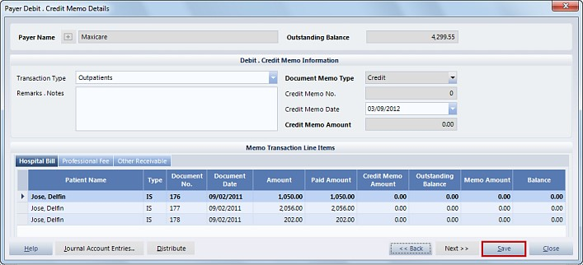

1. After you’re done with all those steps, click the save button. On the password validation entry, input your user code and password, then, click accept button.
2. You will notice that the newly created payer credit memo will be added on the list without a color status, meaning it is For Posting. You can still review it, by clicking the view command button, or by selecting the credit memo details on the sub components. When you’re done viewing, click the close button.
3. If there are inconsistencies that were detected, you can update the record by clicking the edit command button.
4. When you’re done editing, click the save button, and input your user code and password on the password validation entry.
5. If you feel that the record is not needed anymore, you can just remove it, by clicking the delete command button. On the confirm Deletion window, specify the reason for deletion then click Ok to continue, or click Discard to cancel.

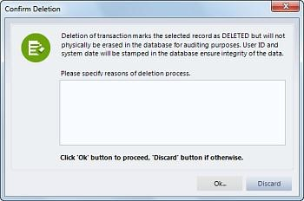

1. If you have already checked the correctness and completeness of the payer credit memo, you can now post it using this button. Take note that after posting, you will no longer be able to edit, or delete a chosen record. After clicking that button, the Confirm Posting window will appear, take time to read the reminder, then, if you want to continue with the process, click ok button, if not click discard.

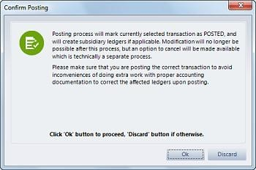

1. After clicking ok, input your user code and password on the password validation entry, then, click accept.
2. You will notice that the posted credit memo will have a posted status represented by a blue color that means the posting was successful.
3. If for some reason a posted payer credit memo is no longer needed, since deletion is now disabled, you can still cancel it, using the void command button.

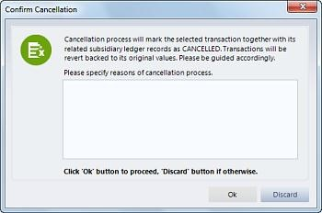

1. On the confirm cancellation window, indicate your reason for cancellation, then, confirm using the ok button. On the password validation entry, enter your user code and password, then, click accept.
2. The selected record will now have a Voided status, represented by a red color that means the cancellation process was successful.
3. Lastly, you can print a selected payer credit memo, by clicking the Print Payer Credit Memo on the sub components.

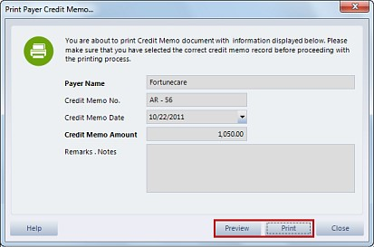

1. The Print payer credit memo window will appear, that contains some of the details of the record. Before proceeding with printing, make sure that all the data are correct, by viewing the record using the preview button.

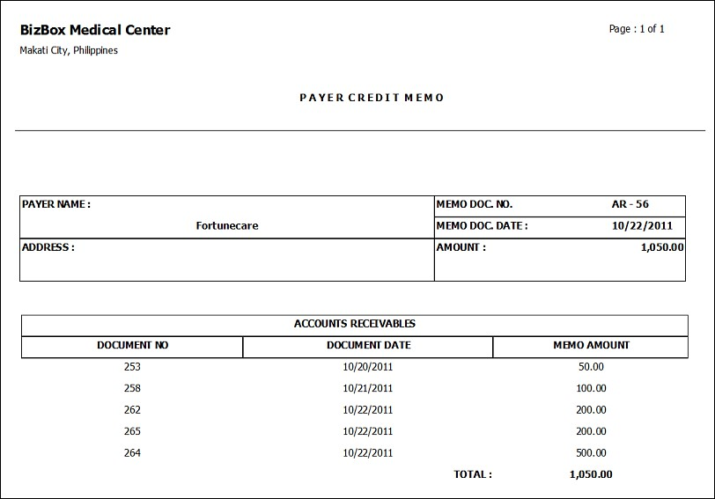

1. After that, you can click print button, or you can also choose close and click print on the previous window.
2. When you’re done printing, click the Close button.

# Payables and Disbursements

Let’s now discuss the different modules under the payables and disbursements group on the Financial Management System. We will also discuss the different processes on how to manage these kinds of records for a more systematic hospital flow and efficient services to the patients. Here are the modules that are included on this group:

## Patient Refunds

The Patient Refund module is used to record the different refunds of the patients based on their excess payments. Here’s a quick process in managing this information in the Financial Management System.

1. On the FMS main window, click the patient Refunds on the main explorer, or from the Core Components menu pad.
2. To create a new record, just select new command button.
3. The Patient Refund List window will appear, you can use the Registry Type dropdown selection list to filter the patient records to be displayed on the list. You can also use the search fields to easily find the patient’s account. Highlight a patient on the list, then, click Select button.

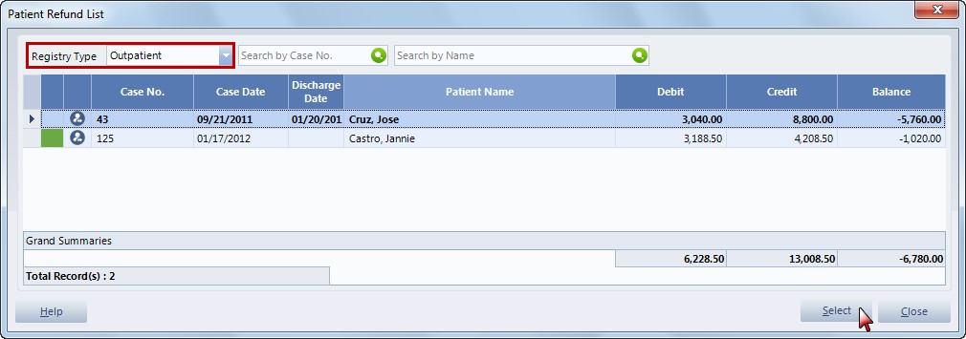

1. The Post Patient Refund window will appear, that shows the amount for refund and other details.

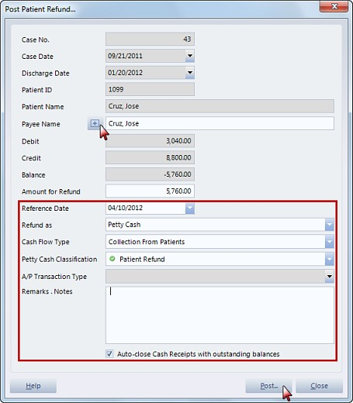

Note:

If you want to select another patient just click the button on the Payee Name, input the payee name on the central database lookup window. If the payee is already on the database, his name will be listed here, you should then verify if that payee is the same person using his name and birth date, then, click the select active record button. You may complete the payee’s information, or just click the Save and Close button.

1. Going back to the Post Patient Refund window, specify the reference date, then, choose from Petty Cash or Accounts Payable as a form of refund. If you chose Petty Cash, it will ask you to select Cash Flow Type, and Petty Cash Classification. On the other hand, if you chose Accounts payable, you need to select the Accounts Payable Transaction Type from the dropdown list.
2. Also indicate the Notes or Remarks, if necessary. There is also a checkbox below that Allows Auto Closing of Cash Receipts with Outstanding Balances.
3. After all those processes, you can now click the Post button. On the password validation entry, input your user code and password then click Accept.
4. You will notice that the new patient refund will now be posted on the list with an active status represented by a green color.
5. You can check if the details are correct and complete, by clicking the view command button or by selecting the patient refund details on the sub components. When you’re done viewing, click the Close button.
6. You can print a selected patient refund voucher, by clicking this button on the sub components.
7. The Print refund voucher window will appear, that contains some of the details of the record. Before proceeding with printing, make sure that all the data are correct, by viewing the record using the preview button. Review all the details if they are consistent, then, you can now click the print button, or you can also choose close, and click print on the previous window.

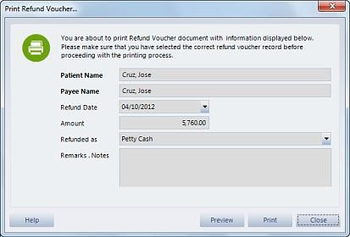

1. When you’re done printing, click the Close button.

## Accounts Payable Vouchers

The Financial Management System can also accommodate the different accounts payable vouchers and manage their records. In addition, all the transactions from the deliveries and receiving modules which are posted in the Vouchers Payable will also be reflected in this module. Here are the different processes that will help you to record, and organize the different information, and records of the accounts payable vouchers.

1. On the FMS main window, click the accounts payable vouchers on the main explorer, or from the Core Components menu pad.
2. To create a new account payable voucher, just click the new command button. On the search entity window, highlight an entry, then, click the select button.

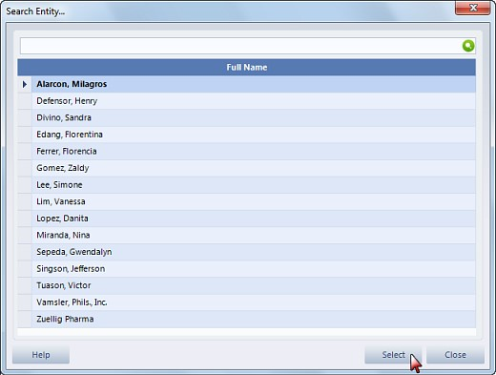

1. The accounts payable voucher details will appear, select Accounts Payable category from Accounts Payable or Professional Fee. If you select Accounts Payable, you just need to specify the Terms and A/P Voucher Date. Then on the transaction details below, click the add button, select from the dropdown selection list the transaction type, department, amount, and if applicable the discount rate, the VAT rate and the EWT or expanded withholding tax and the remarks.

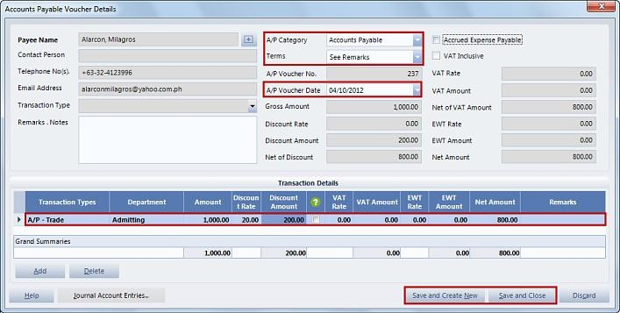

1. But if you select Professional Fee category, you should enter the transaction type, terms, accounts payable voucher date, and gross amount. Then, if you want to apply a discount, just input the discount rate on its field, if it is inclusive of VAT, enable this checkbox, and enter the VAT rate on its field. In addition, if there is an expanded withholding tax, just put its rate on the EWT Rate field. After that, enter your remarks or notes on the space provided. You can now save the new accounts payable voucher by using either of this two buttons. You can save and create a new record by clicking this button, or you can save and close by selecting the other one.

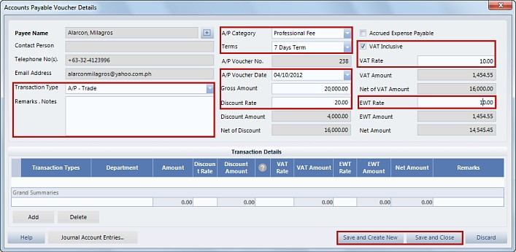

1. On the password validation entry, input your user code and password, then, click accept button.
2. You will notice that the new record will be added on the list. You can review it, by clicking the view command button, or click the AP Voucher details on the subcomponents. On the accounts payable voucher details, make sure that all the details are complete, and correct. After viewing, just click the close button.
3. If there are errors that were detected while viewing, you can still update it, using the edit command button.
4. On the Account payable voucher details, modify the necessary information on their fields, then, click save and close when you’re done. Input your user code and password on the password validation entry, then, click accept button.
5. If you feel that the record is not needed anymore, you can just remove it, by clicking the delete command button. On the confirm Deletion window, specify the reason for deletion, then, click Ok to continue, or click Discard to cancel.

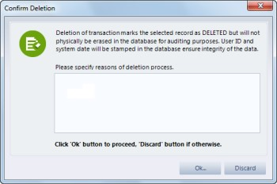

1. After checking the data, it is now ready to be posted. Click the post command button, then, on the Confirm Posting window, make sure to read these reminders about the posting process before confirming. Click ok to continue, or discard to cancel. On the password validation entry, input your user code and password, then, click accept button. You will now notice that the record was successfully posted because it has a posted status, represented by a blue color.

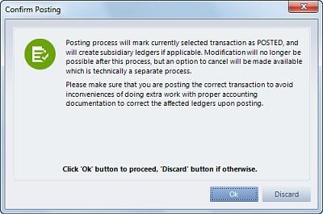

1. After posting, revision and deletion will be disabled, so if there are records that need to be removed from the list, all you can do is to cancel, using the void command button.
2. On the confirm cancellation window, you will be informed that the selected record will be marked as cancelled, which means the transactions will be reverted back to their original values. You should also specify the reason for cancellation on the space provided. To continue with the process click ok, or you can cancel by selecting discard.

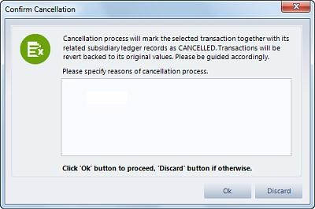

1. You will now notice that the selected A.P. Voucher was successfully cancelled because it will be tagged as Voided, which is represented by a red color.
2. You can print a selected accounts payable voucher, by clicking this button on the sub components.
3. The Print accounts payable voucher window will appear, that contains some of the details of the record. Before proceeding with printing, make sure that all the data are correct, by viewing the record using the preview button.

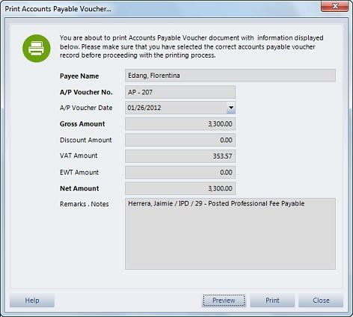

1. Review all the details if they are consistent, then, you can now click the print button, or you can also choose close, and click print on the previous window.
2. When you’re done printing, click the Close button.

### Post Guaranteed PF Payables

Using the Financial management system, we can also post guaranteed professional fee payables that are paid by the guarantors for the patients in the hospital. This will help organize the payment processes for the different doctors in the hospital.

1. On the Accounts payable vouchers, let’s start on the process of posting guaranteed PF payables by clicking this button on the processing and queries, under the sub components.
2. The post guaranteed P.F. payables will appear, use these filter options for the payables to be listed below, then, click the apply filter preferences button.
3. The PF Payables will now be listed, to select just enable their checkboxes, then, click next button.

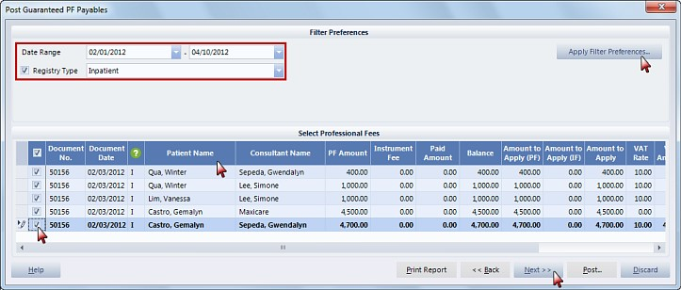

1. The selected payables will now remain on the list. After that, click the post button.
2. Enter your user code and password on the password validation entry then click accept button.
3. The guaranteed professional fee payable will now be added on the list, with a posted status, represented by a blue color.

### Post Cash PF Payables

This process will organize the payments made by the patients for the different doctors in the hospital.

1. On the Accounts payable vouchers, let’s start on the process of posting cash PF payables by clicking this button on the processing and queries on the sub explorer.
2. The post cash P.F. payables will appear, use these filter options for the payables to be listed below, then, click the apply filter preferences button.
3. The PF payables will now be listed, to select just enable their checkboxes, then, click next button.

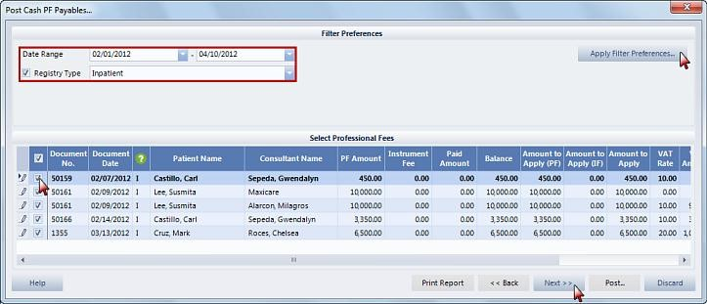

1. The selected payables will now remain on the list. After that, click the post button.
2. Enter your user code and password on the password validation entry then click accept button.
3. The cash professional fee payable will now be added on the list, with a posted status, represented by a blue color.

### Post Readers Fee Payables

In the financial management system, it is also needed to post the readers fee payables for the doctors in the hospital that are reading the different examination results of the patients. Here’s a quick process on that:

1. On the Accounts payable module, select post readers fee payables button on the processing and queries under the sub explorer.
2. The post readers fee payables window will appear. Use these filter preferences to view the doctors’ readers fee that should be posted.
3. You also have the option to filter the transactions according to Remit Tagging Types. If you select the RF Cash Remit Tagging, this pertains to the transaction with outright payment from the Patients. On the other hand, if you select RF Charge Remit Tagging, this pertains to the transactions that the application is from the guarantors, then, if you select Charges without specified reader’s fee, this pertains to charges that are not yet read by the doctor. Lastly, if you select RF Charges, or Cash Remit Tagging, this pertains to the transactions that are paid thru cash and guarantors.
4. The records will be shown on the list, enable the checkmarks of the entries you want to post, then, click next button when you’re done.

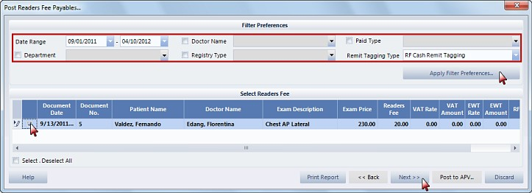

1. The chosen ones will remain on the list. Double check the correctness of all the details, then, click the post to APV button.
2. Input your user code and password on the password validation entry then click accept button.
3. The reader’s fee payable will now be shown on the list with a posted status, represented by a blue color, meaning the process was successful.

### A/P Consolidated Subsidiary Ledger

Using this feature of the financial management system, we can view the consolidated account payables subsidiary ledgers. In addition, all payables from Vendors, Doctors and Others will be reflected in this report module. Here’s a quick process on that:

1. On the Accounts Payable Vouchers module, select A/P consolidated subsidiary ledger on the processing and queries under the sub explorer.
2. On the Search entity window, highlight an entry on the list, then, click select button.
3. The subsidiary ledger for the selected entity will appear, use the following filter preferences to view the accounts payable.
4. On the list, you can view the disbursement voucher details, or the debit or credit memos by clicking the button on the 5th column.

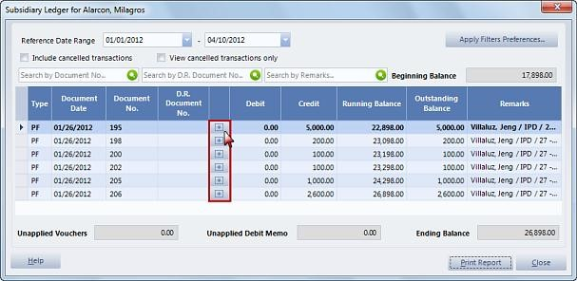

1. Here, you can check if the information and details are complete and correct. When you’re done, click the close button.

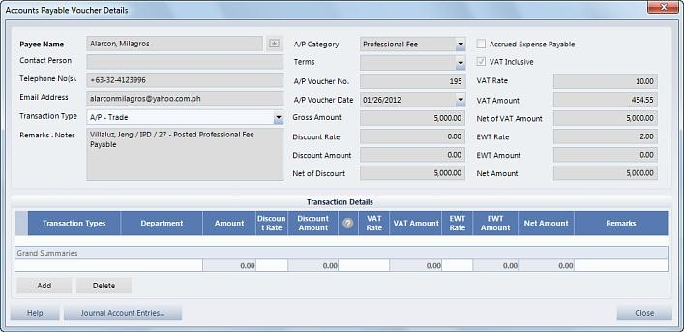

1. Going back to the previous window, you can print the report by clicking the Print Report button.

### Vendor Supplier Subsidiary Ledger

We can also view the more Detailed information about vendors, and suppliers using this feature in the Financing Management System. Here’s a quick process on that:

1. On the Accounts Payable Vouchers module, select vendor supplier subsidiary ledger on the processing and queries, under the sub explorer.
2. On the Search entity window, highlight an entry on the list, then, click select button.
3. The subsidiary ledger for the selected entity will appear, use the following filter preferences to view the accounts payable.
4. On the list, you can view the disbursement voucher details, or debit, or credit memos by clicking this button.

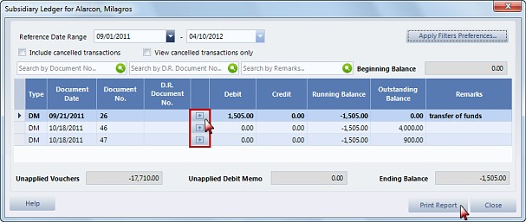

1. Here, you can check if the information, and details are complete and correct. When you’re done, click the close button.

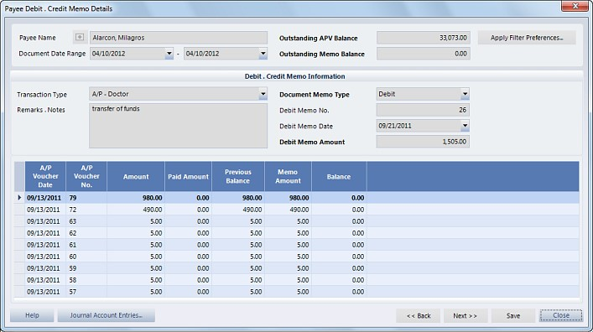

1. Going back to the previous window, you can print the report by clicking the Print Report button.

### Consultants Subsidiary Ledger

Another subsidiary ledger that we can access is that of the consultants. Here’s the process:

1. On the Accounts Payable Vouchers module, select consultants subsidiary ledger on the processing and queries, under the sub explorer.
2. On the Search entity window, highlight an entry on the list, then, click select button.
3. The subsidiary ledger for the selected entity window will appear, use the following filter preferences to view the professional fees.

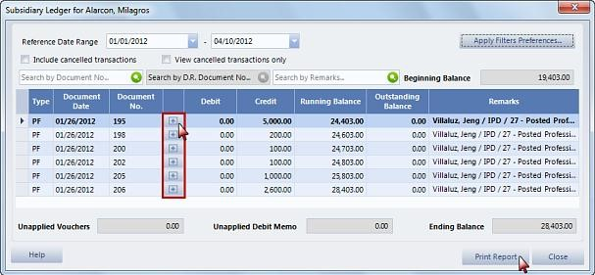

1. On the list, you can view the disbursement voucher details or debit or credit memos by clicking the button on the 4th column. Here, you can check if the information and details are complete and correct. When you’re done, click the close button.

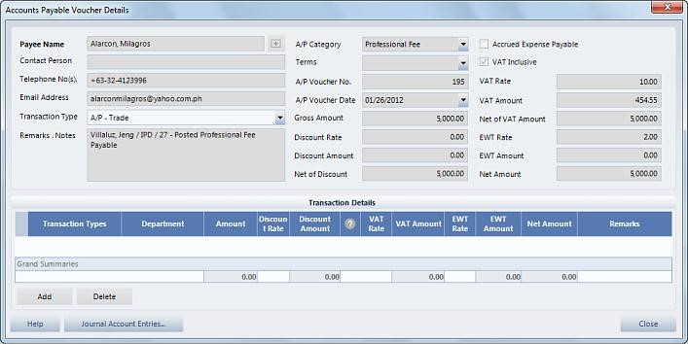

1. Going back to the previous window, you can print the report by clicking the Print Report button.

# Disbursement Vouchers

The disbursement vouchers are the payments of the hospital to the different suppliers. This includes direct expenses and payables from suppliers and for accruals. Here’s the process of managing the records of the disbursement vouchers in the financial management system:

## Check Voucher

Using the disbursement vouchers module, we can process both cash and check vouchers. These processes are basically the same so we will just show you the process of managing check vouchers as your reference. Here’s a quick process on that:

1. In the disbursement vouchers module, you can create a new disbursement record, by clicking the new command button.
2. On the search entity window, you can use this search field to easily find the record that you’re looking, then, click the select button.
3. On the credit details, specify check voucher as voucher type, then, click the continue button.

Note:

If you selected Cash Voucher as Voucher Type, the process is just the same as compared with the Check voucher, the only difference is that there will be no check payment tab, instead there will be a cash field.

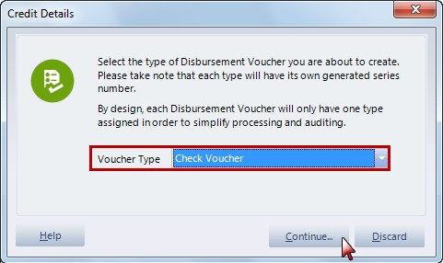

1. The disbursement voucher details will appear. Indicate the following information on these fields: payment category, cash flow type, and voucher date.
2. If you selected payable as the payment category, you will notice that the check payment and the accounts payable application tabs will be enabled below, while if direct expense is selected, the expense transaction type

and other credit transactions will also be enabled in addition to the previous tabs. If the payment is advance or deposit, just enable its checkbox.

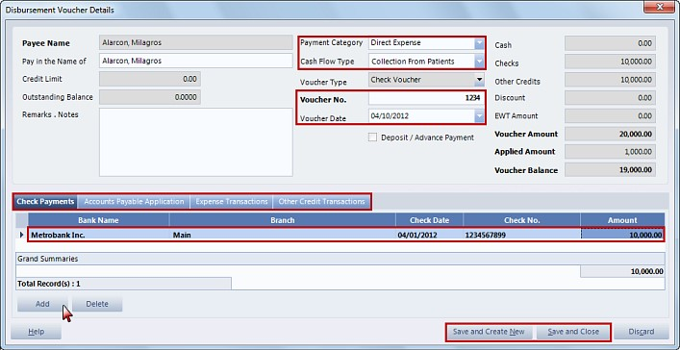

1. On the lower part of the window, select check payment tab, click add button to enter the check details. Specify the following information: bank name, branch, check date, check number, and amount.
2. On the accounts payable application tab, enable the entries to be paid, you can enter the applied apv, and also the discount on their specific columns.

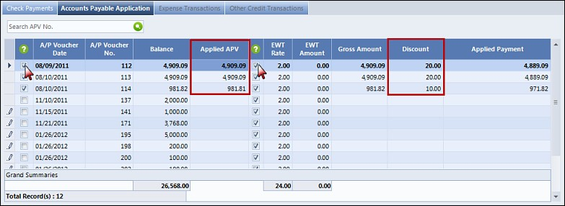

1. On the Expense Transaction tab, click add button then enter the following information: transaction type, amount and the department.

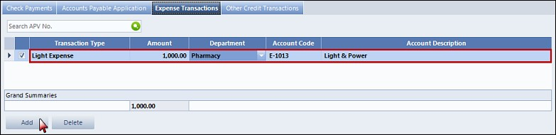

1. On the Other Credit Transactions tab, click Add button then enter the following information: Transaction Type, Amount and Department.

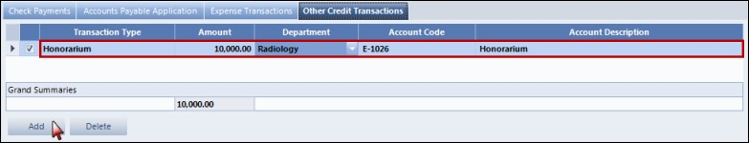

1. When you’re done with all those steps, you can now save the disbursement record using either of these two buttons: save and create new or save and close. On the other hand, you can cancel the process by clicking the close button.
2. After that, you will notice that the new disbursement record will be added on the list. You can review it, by clicking the view button, or the Voucher details on the sub components.
3. When you’re done viewing the voucher, you can now go back to the disbursements main window by clicking the close button.
4. If there are records that are no longer needed on this module, you can just cancel the record by clicking the void command button.
5. On the confirm cancellation window, enter the reasons for cancellation on the space provided then click ok button.
6. On the password validation entry, enter your user code and password, then, click accept button. You will then notice that the disbursement voucher will have a voided status, represented by a red color.

## Print Cheque

You can print the checks to be issued to the suppliers using this feature on the Disbursement Vouchers module. Please take note that this is applicable for check vouchers only. Here’s the process.

1. On the Disbursement Vouchers module, select a check voucher on the list, then, click Print check on the sub components.
2. On the print check window, select an entry from the list, by enabling its checkbox. Before printing, click the preview first to review the details to be printed. To print, you can click the printer icon on the report preview, or you can click the close button, and click print button on the previous window.

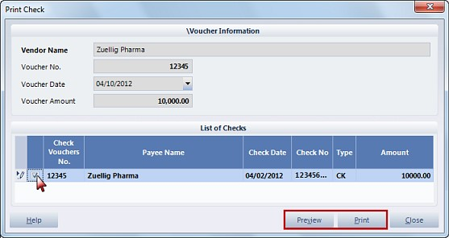

1. When you’re done, click the close button and return to the disbursement vouchers main window.

## Print Voucher

Another feature of the financial management system is that you can print the different disbursement vouchers. Here’s the process.

1. On the Disbursement vouchers module, select a voucher on the list, then, click the Print Voucher button on the sub components.
2. When the print disbursement voucher window appears, review the details about the voucher on this window. We can also click the preview button to ensure the correctness and completeness of the details. To print, you can click the printer icon on the report preview, or you can click the close button, and click print button on the previous window.

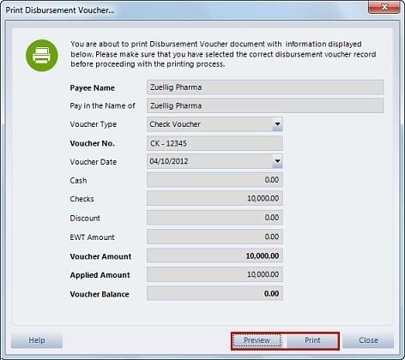

1. When you’re done with all those processes, click the close button.

## Reapply Voucher

We can reapply the different vouchers for the partially applied, and also for the unapplied vouchers.

1. On the Disbursement vouchers module, select a partially applied voucher, or an unapplied voucher from the list, then click Reapply voucher button on the subcomponents.
2. The application of voucher to payable window will appear. On the list, select the accounts payable vouchers, by enabling their checkboxes.
3. For some of those entries, you can enable this checkbox, if it is vat, inclusive and you can also enter the EWT rate. In addition, you also have an option to indicate the discount amount. On the other hand, specifying the applied amount is applicable to all the vouchers on the list. When you’re done, click the next button.

Note:

Remember that the Applied A.P.V. of a certain voucher should not exceed the balance. After that, input your remarks or notes here, if it is necessary.

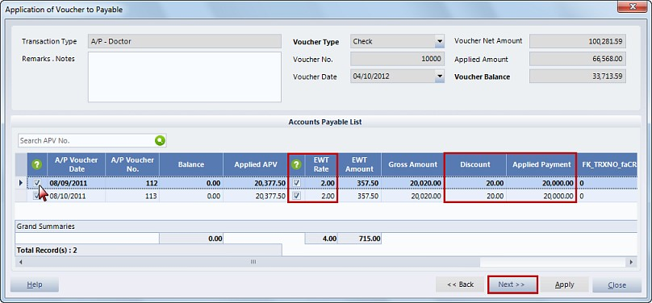

1. You will notice that the ones selected will remain on the list. You can now click the apply button.
2. On the password validation entry, enter your user code and password, then, click the accept button.
3. You will notice that the disbursement voucher record will now have a status, that will depend if the check voucher amount is fully used, or not.

## Amend Voucher

If there are inconsistencies that were detected, we can update the record using this feature on the Disbursement Vouchers module.

1. Instead of using the edit button, we will use the amend voucher button on the sub components to make changes on the voucher.
2. Once you click that button, the disbursement voucher details window will appear. Please take note that not all information in the disbursement vouchers can be edited. You can just update the following information on their respective fields: pay in the name of, voucher no. , voucher date, and the details on the different tabs namely: check payments, account payable application, expense transaction and other credit transactions.

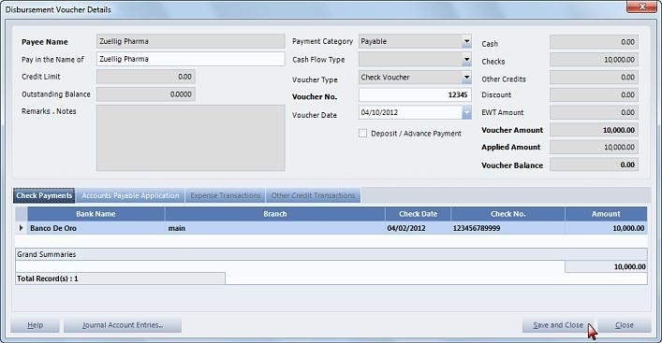

1. When you’re done, click the save and close button. On the password validation entry, enter your user code and password then click accept button.

# Releasing of Checks

From the different disbursement vouchers more specifically to the check vouchers, you can now post the checks to be released for the different suppliers. To do this process, please follow these steps:

1. On the Releasing of checks module, select the new command button.
2. On the post releasing of issued checks window, you can view the different checks that were issued by the hospital. You can use these filter options to be able to sort, and access the different checks.
3. You can now select the checks, by enabling their checkboxes.

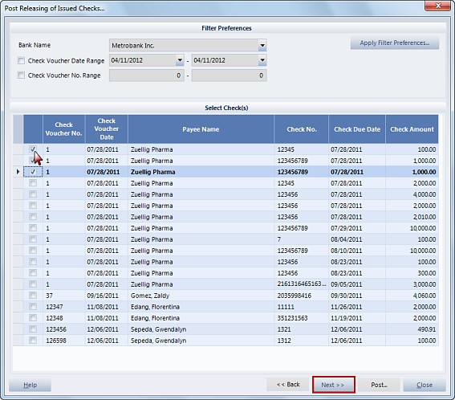

1. When you’re done with the selection, click the next button, and the selected checks will remain on the list.

Double check the entries, then, click the post button.

1. On the password validation entry, enter your user code and password, then, click accept button.
2. The released check will now be added on the main window of this module.
3. If a released check is erred, you can just click the void button, to cancel the released check.
4. On the system alert window, click yes to confirm cancellation, or no to cancel the process.
5. You will now notice that the voided record will no longer appear on the list.

# Petty Cash Vouchers

The petty cash vouchers are small amount of disbursements which are applicable for Emergency Purchases, Patient Refund and other expenses of the hospitals. In the financial management system, we can also manage these records. Here’s the quick process on that:

1. To create a new petty cash voucher, click the new command button. On the petty cash voucher details, enter the following information on their fields: Payee name, select the cash flow type on the dropdown list, petty cash date and amount issued. Using the petty cash classification details tab, you can specify where the money was used. Click add button to create a new entry, select the description from the drop down selection list then the amount and the remarks if necessary. Note:

You can add another one, by clicking the add button again.If for some reason, you want to remove a petty cash classification, you can click the delete button.

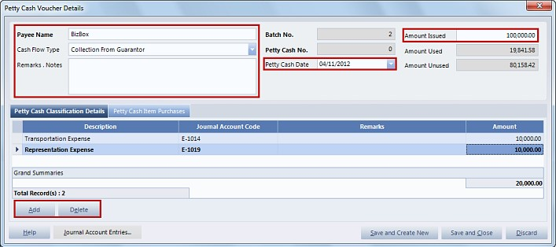

1. On the other hand, the petty cash item purchases are the items that are purchased by the hospital. This is usually applicable for the emergency purchases in case the items urgently needed are not available in the hospital. To add an entry, just click the add button.
2. The multi-department item selection window will appear, select the appropriate items from the different departments by enabling the items’ checkboxes.

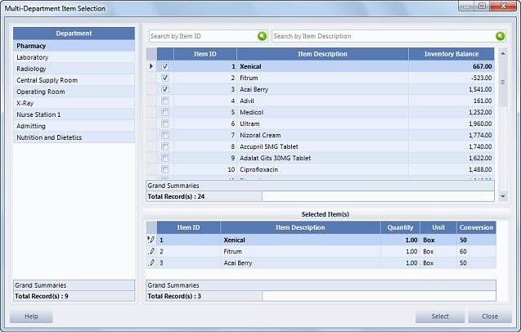

1. The selected items will now be added on the petty cash item purchases list. If an item is no longer needed, just click the delete button.
2. You can also specify the quantity needed, the price of the item, and enable this checkbox, if it is vatable. After that, input the amount to be issued, based on the amount used.

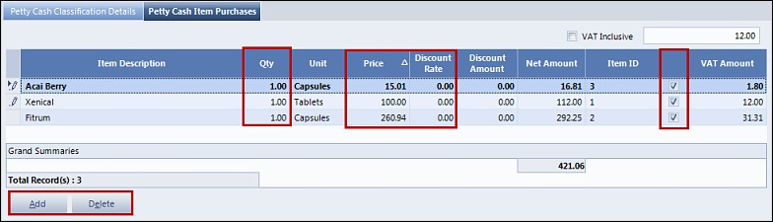

1. When you’re done, you can now save the petty cash voucher using these two buttons: save and create new or save and close.
2. On the password validation entry, enter your user code and password, then, click accept button.
3. You will now notice that the record will be added on this module’s main window.
4. You can check if the petty cash voucher is correct, and consistent, by clicking the view command button, or by using the petty cash voucher details button on the sub components.
5. When you’re done viewing, just click the close button and return to the main window.
6. If there are errors that were detected, you can update it, by clicking the edit command button.
7. On the petty cash voucher details, update the necessary information, then, click save and close when you’re done.
8. To confirm, enter your user code and password on the password validation entry, then, click accept button.
9. If you think that the record is no longer needed, and should be removed from the petty cash list, just click the delete command button. Specify the reason for deletion, then, click ok to continue, or click discard to cancel. Remember that only unposted records can be deleted.
10. When you think that the record is now final, you can now post it, using this command button.
11. On the confirm posting window, click ok button to continue with the process, but if you wish to cancel, click the discard button.

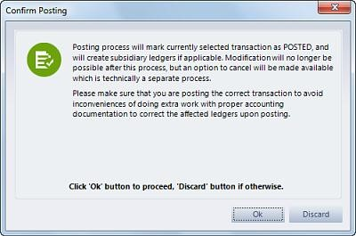

1. On the password validation entry, enter your user code and password, then, click accept button.
2. You will now notice that the petty cash voucher will have a blue status meaning it is now posted.
3. Once the petty cash voucher is posted, it can no longer be deleted, but you can declare it as voided by clicking its command button.
4. On the confirm cancellation window, indicate the reason for cancellation, then, click ok to continue.
5. The password validation entry will appear, enter your user code and password, then, click accept button.
6. You will now notice that the petty cash voucher will have a voided status, represented by red color.
7. Lastly, you can print the petty cash voucher, by selecting print petty cash voucher on the sub components.
8. The print petty cash voucher window will appear, click preview button to review the details. Once you make sure that all the information, and details are complete and correct, you can now print it by clicking the printer icon on the report viewer or you can close this window and select print button on the previous window.

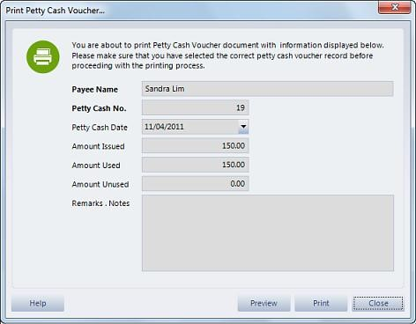

1. When you’re done with all those processes, just click the close button.

# Payee Debit Memos

The payee debit memo of the financial management system accommodates, and manages the debit adjustments of the payables in the hospital. Here’s a quick process on that:

1. By clicking the new command button, we can create a debit memo wherein the creation of it will be for a specific payee and the basis for tagging will be per transaction document. On the other hand, we can also create a debit advice that will allow you to create debit advice to the following transactions of accounts payable.
2. Let’s start with the process of creating a debit memo, select this button on the disbursement option window.
3. On the search entity window, highlight the payee, then, click the select button.
4. The payee debit credit memo details will appear, use these filter options to access the different accounts payable. Select an Accounts Payable Transaction, by enabling their checkboxes, after that, you can update the memo amount on its column.

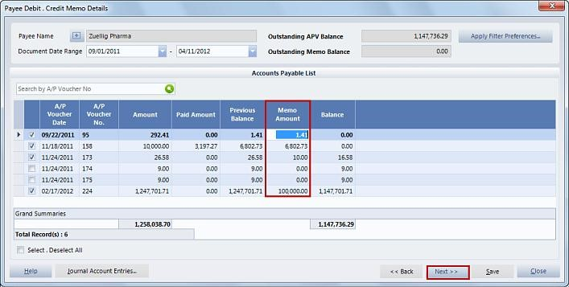

1. Click next, when you’re done. The selected payable will remain on the list. Input the necessary information on these additional fields. Transaction type, remarks, the debit memo date and remarks if applicable. In addition, you can still update the memo amount on its column.

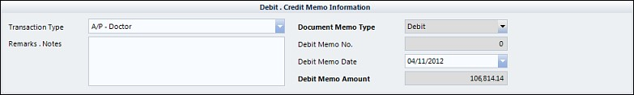

1. When you’re done with all those processes, click the save button. On the password validation entry, enter your user code and password, then, click accept button.
2. You will notice that the new debit memo will be included on the payee debit memos list.
3. You can then check the completeness and consistency of the record by clicking the view command button, or the debit memo details button on the sub components.
4. Review the information on the payee debit credit memo details, and when you’re done click the close button, and return to the module’s main window.
5. If there are mistakes that were detected, you can still update the record, by clicking the edit command button.
6. Update the necessary information, and details on their respective fields, then, click this button to save the changes.
7. On the password validation entry, input your user code and password, then, click the accept button.
8. If for instance the debit memo record is no longer needed and should be removed from the list, you can use this button to delete the record. Remember that deletion cannot be done if the debit memo is already posted.
9. On the confirm deletion window, enter the reason for deletion. Click ok to continue, or click Discard to cancel.
10. Let’s go to the posting process, once you think that the record is final and should be executed, then it should be posted using this command button. The confirm posting will appear, click ok to continue with the process, or click discard to cancel. On the password validation entry, enter your user code and password, then, click accept button.

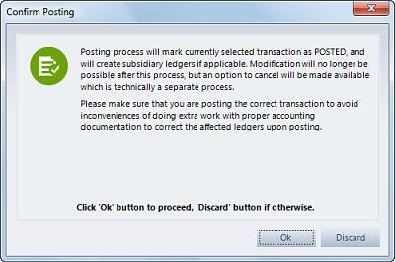

1. You will notice that the record will now have a blue status meaning that it was successfully posted.
2. Since the deletion is no longer applicable to posted debit memos, a remedy for posted records that need to be removed from the list is to cancel it, using the void command button.
3. On the confirmation window, enter the reason for cancellation. Then, click ok to confirm.
4. On the password validation entry, enter your user code and password, then, click accept button.
5. You will then notice that the debit memo will be voided, represented by a red color.

## Print Payee Debit Memos

Another process is the printing of debit memos, please check this video for the details.

1. To do this process, select an entry from the list, then, click this button on the sub components.
2. On the print payee debit memo window, review all the necessary details, and information, by clicking the preview button.

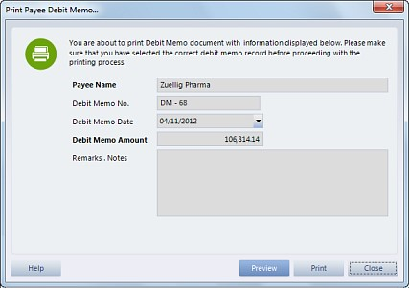

1. Once you’re done and confirmed that the information is complete, you can now print the document, using the printer icon on the report viewer or you can just click the close button and select the print button on the previous window.

## Reapply Debit Memo

In this video we will show you how to re-apply debit memo. Please take note that re-application is not allowed for none MMS Purchase Return transactions.

1. We can reapply the records for unapplied debit memos, or the ones with gray color status, using Reapply Debit Memo on the subcomponents.
2. On the payee debit-credit memo details, use these filter options to access the different accounts payable.
3. Select the account Payable to be adjusted on the list, by enabling the checkbox, then, click the next button. The selected payable will remain on the list. Update the following information if necessary, remarks, and debit memo date.

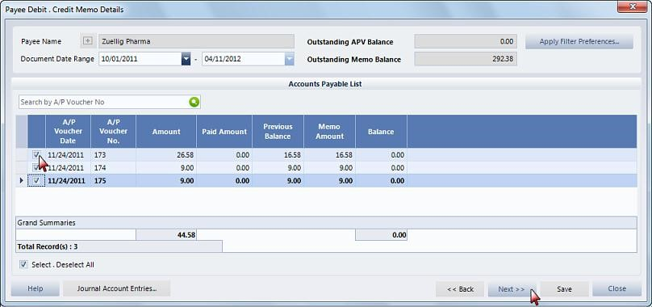

1. When you’re done, click the save button. To confirm enter your user code and password on the password validation entry, then, click accept button.
2. You will then notice that the debit memo will be posted, represented by a blue color, meaning the reapplication was successful.

## Debit Advice

The debit advice is the application of the adjustment for the payables wherein the payment is deducted by the bank to the hospital account balance, and transferred the amount directly to the account of the vendor.

1. Let’s now go to the managing the debit advice using the payee debit memos module. After clicking the new command button, select the debit advice button on disbursement option window.
2. On the debit advice window, use the filter preferences to view the accounts payable list.
3. To select an entry, just enable their checkboxes. By clicking this button, you can view the composition of a certain account payable, such that, you can choose to process specific entries.
4. You will notice that the selected entries will be added on the other list below, wherein you can edit the amount to apply, set the entry if it is vat inclusive or not by enabling this checkbox, its EWT rate and discount.

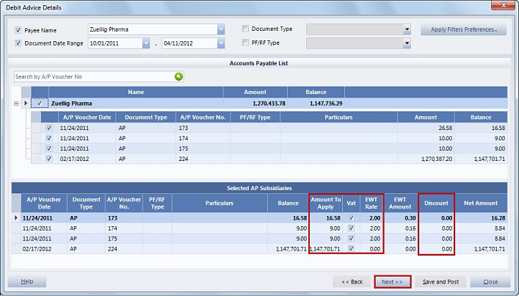

1. When you’re done, click the next button. The selected entries will all be compiled in a single list. Provide the following information on their fields, reference bank, Remarks and notes, if necessary, debit memo date, and transaction type.

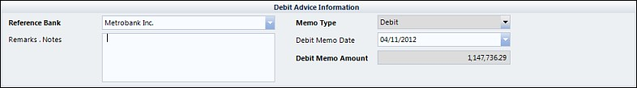

1. You can still update the amount to apply, vat, and discount, if you want to.
2. After all those processes, you are now ready to save and post the debit advice by clicking its button.
3. The confirm posting window will appear, click ok to continue, or discard to cancel the process.
4. You will now notice that the debit advice will be added on the list with a posted status represented by a blue color.

Note:

The processes of viewing, voiding and reapplying the debit advice are the same as the process of the debit memos.

# Financial Accounting Script

In this part of the Financial Management System, we can manage the different components of the financial accounting that involves the journal vouchers, journal entries, audit journal entries and general ledgers. Here are the processes that should be followed when managing the different records in this module:

## Journal Vouchers

Let’s start with the journal vouchers; they are used in the manual journal entries specifically when there are adjustments from other transactions. Here’s a quick process on managing these records on the system:

1. In creating a new journal voucher, you should click the new command button.
2. The Journal Voucher details window will appear, wherein you should input the following information:

description of the voucher, remarks or notes if applicable, reference date, and journal voucher type. You can also enable the checkboxes if the voucher is for closing entries or adjusting entries.

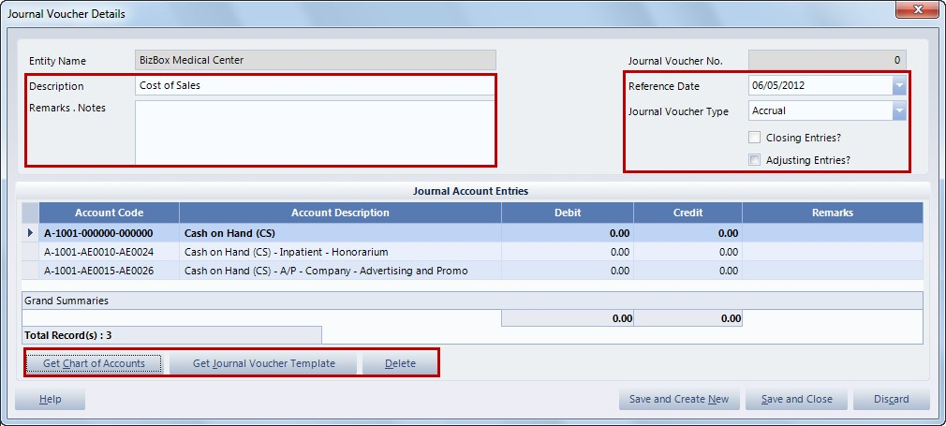

1. On the lower part of the window, you should enter the journal voucher entries using these buttons. You can click get chart of accounts then on the mother chart of account selection list, use the filter options to filter the entries to be listed and easily select entries. To select, just enable their checkboxes then click the select button.



1. On the other hand, you can also select from the journal voucher template which is already composed of different chart of accounts. If there are unnecessary entries that were selected, you can just remove them from the list by clicking the delete button.
2. When you’re done with the selection, you can now specify the debit, and credit values on their columns. Remember that the total debit for all the entries should be equal to the total credit, and also they should be greater than zero.

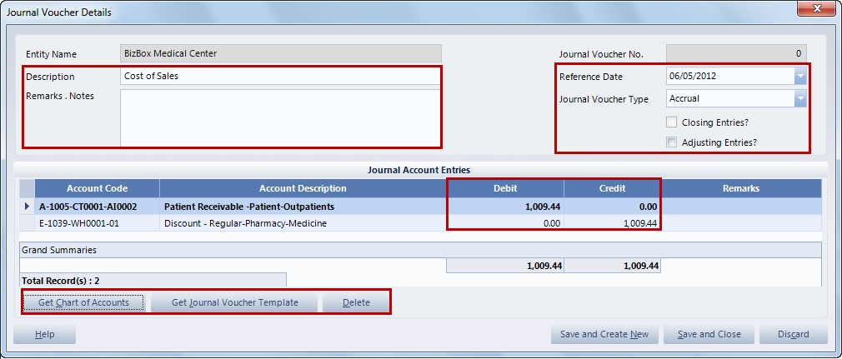

1. After all those processes, you can save the new journal voucher by clicking save and createnew or save and close buttons.
2. You will then notice that the new journal voucher will be added on the list. You can still review the journal voucher, by clicking the view command button, or by selecting the journal voucher details on the sub components.
3. If there are inconsistencies that were detected, you can update the record by clicking the edit command button. Remember that only the unposted vouchers can be edited. When you’re done editing, click the save and close button.
4. If you feel that the record is not needed anymore, you can just remove it, by clicking the delete command button. Take note that only unposted vouchers can be deleted. On the confirm deletion window, enter the reason for deletion on the space provided then click ok to continue or click discard to cancel the deletion.
5. If you have already checked the correctness and completeness of the journal voucher, you can now post it with the post command button. Take note that after posting, you will no longer be able to edit or delete a chosen record. The Confirm Posting window will appear, take time to read the reminder then click ok to continue.

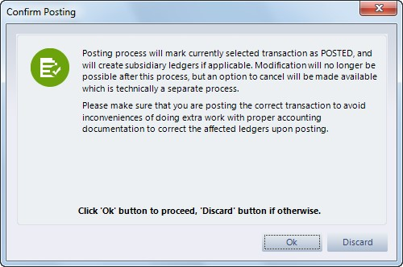

1. You will notice that the journal voucher will now have a posted status represented by a blue color. Take note that the auto generated Journal Voucher from the adjustments made in the HIS, PHIC, MMS will also be reflected in the Journal Vouchers Module as posted.
2. If for some reason a posted Journal voucher is no longer needed, since deletion is now disabled, you can still cancel it, using the void command button. On the confirm cancellation window, indicate your reason for cancellation then confirm using the ok button.

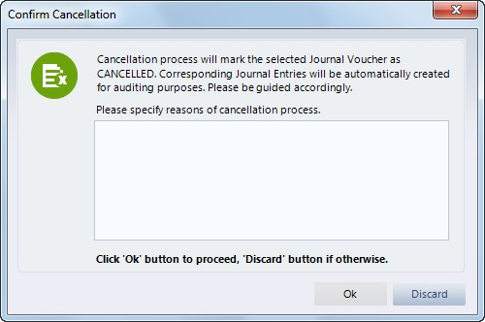

1. The selected record will now have a Voided status, represented by a red color.
2. Lastly, you can print a selected journal voucher by clicking Print Journal Vouchers on the sub components. The Print journal voucher window will appear which contains some of the details of the voucher. Before proceeding with printing, make sure to view the record first, using the preview button.

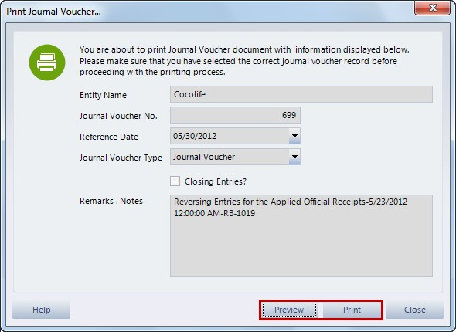

1. Review all the details if they are complete and correct. After that you can click the printer icon, or you can also choose close and click print on the previous window.

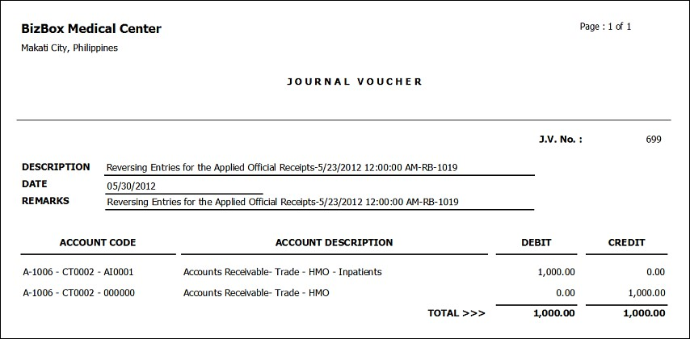

1. When you’re done printing, click the Close button.

**View Print Journal Vouchers**

We can also view, and print the journal vouchers report using this feature on the Financial Management System.

* 1. Given that we are on the Journal vouchers module, click this button on the processing and queries on the sub explorer.
  2. On the journal vouchers report window, you can access the different reports of the journal vouchers. Specify the reference date to sort the records to be shown then indicate the report option and status.
  3. After that click Run Report button for the records to be listed.

Here’s the preview of the report (Journal Vouchers Summary Report):

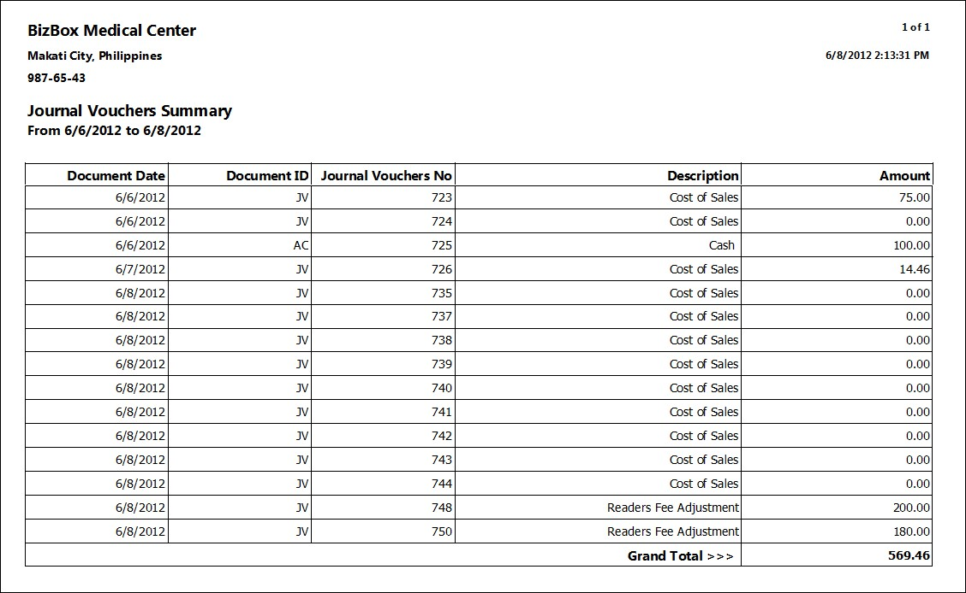

Journal Vouchers Detailed Report:

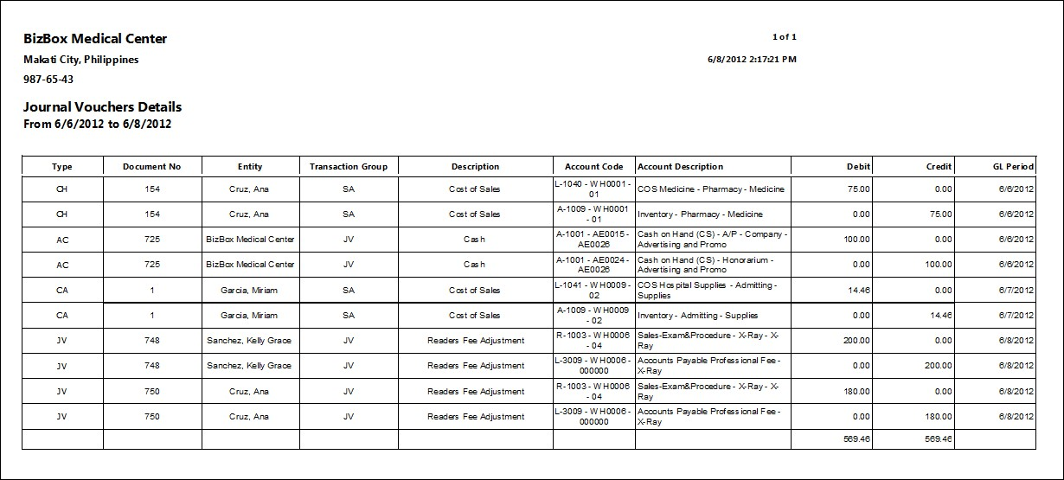

* 1. Check the entries if they are correct and complete then you can now print the document, using the printer icon above.
  2. When you’re done printing, just click the close button, and return to the journal vouchers main window.

## Journal Entries Inquiry

The journal entries inquiry is where all the journal entries and transactions from Hospital Information System, Material Management System, PhilHealth Information System, and Financial Management System will be posted.

1. Upon selecting the journal entries inquiry module, you can access the journal entries from the different systems. You can use these filter preferences to sort the entries to be listed.
2. There are different Journal books that pertain to different transactions in the hospital system: the sales pertain to the processes of post charges, rendering of requisitions, direct render, cash transactions, and room charges. All the entries applicable to sales book are generated from the said charges that will be reflected as journal entries.

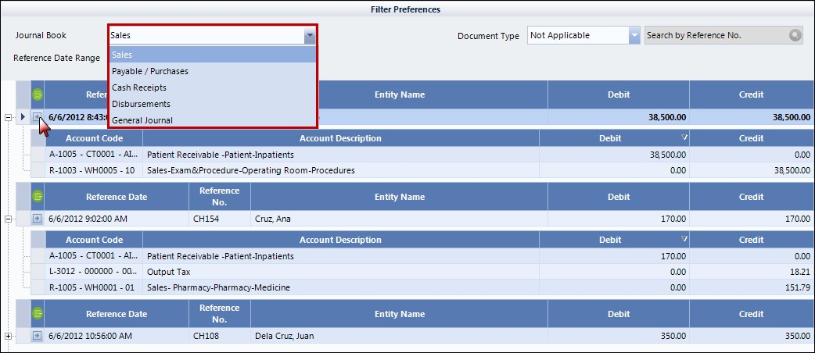

1. On the other hand, the payable, or purchases came from the patient refunds, that are tagged as payable, the posted payables from deliveries and receivables, and the manually entered accounts payable vouchers.
2. Next is the cash receipts, they are the cash collections from inpatients, outpatients, emergency patients, and guarantors.
3. The disbursements are from the check vouchers from the disbursement module.
4. And the General journals are other journal entries not included in the journal books specified previously.
5. In the list of journal entries, you will notice that the records are summarized in this way, but you can also click the (+) button to access the details and composition of these journal entries.

## Audit Journal Entries

The audit journal entries are the records that are from the process of posting journal entries to general ledgers. Here are the processes you should know for you to manage the different records in this module.

1. To create a new audit journal entry just click the new command button.
2. The Posting of Journal Entries as Audited window will appear. Use these filter preferences to show the journal entries to be selected below. To select, just enable the checkboxes.

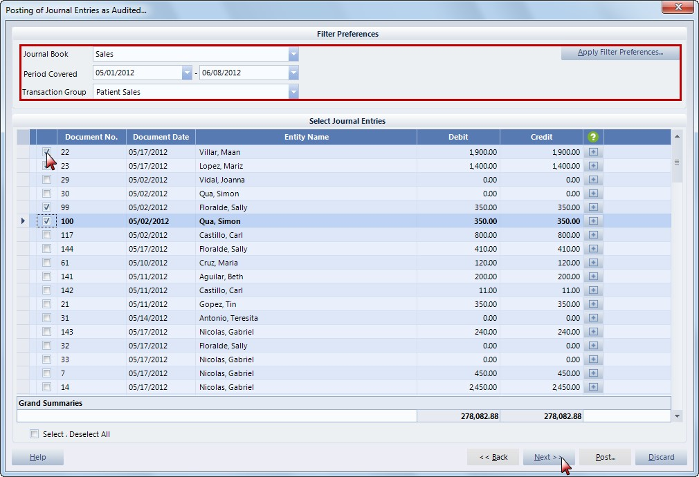

You can click the (+) button to view the details of the journal account entries. You can also manage the journal account entries by clicking get chart of accounts wherein you can select from mother chart of account selection list. After the selection, enter the appropriate information on the debit and credit columns. You can also remove an entry by clicking the delete button. Once you’re done with that, click save and close button or if there were no changes made just click the discard button.

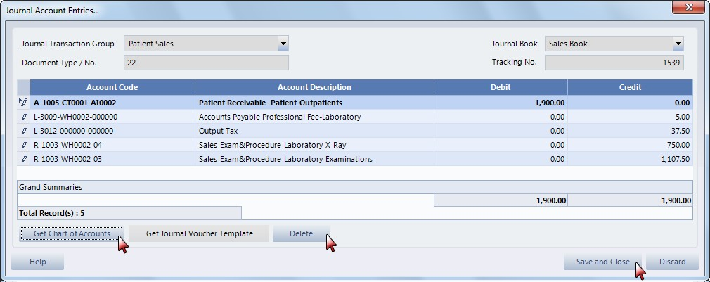

1. Going back to the previous window, click the next button. The journal entries selected will remain on the list, check if they are correct then click the post button. On the password validation entry, enter your user code and password, then, click accept button.

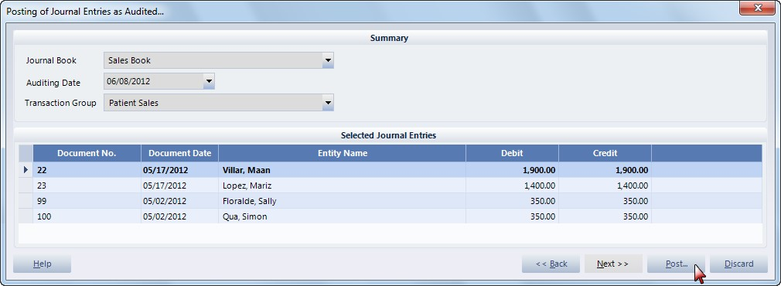

1. The new audit journal entry will now be reflected on the list. You can review the record, by clicking the view command button or by clicking the audited journal entry details on the sub components.

## General Ledger

The general ledger consists of all the posted journal entries from the audit journal entries module. You can use the filter options to filter the journal entries that will be shown on the list. Using the include closing entries checkbox, you can include the closed nominal accounts whose balance were zeroed out.

#### View Print Report

You can view and print a selected report of a journal entry by selecting view print report on the sub components. Here is a sample report preview:

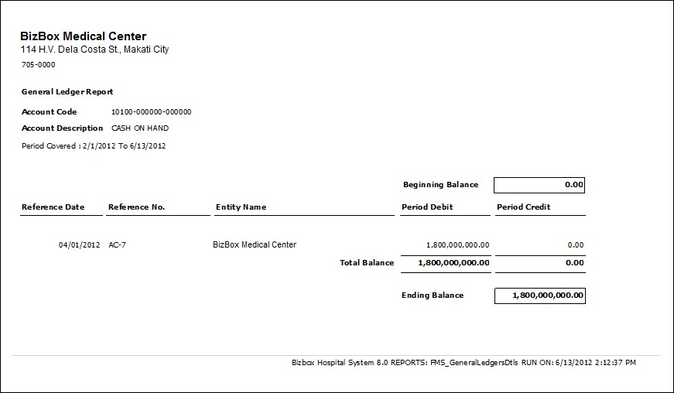

#### Period Posting

This process will close nominal accounts and journal entries in a given period. Here’s a quick process on that:

1. Click Period Closing on the Processing and Queries on the sub explorer. On the period closing details window, the nominal accounts transaction will be listed on a given reference date range. Click next button when you’re done selecting the appropriate period.

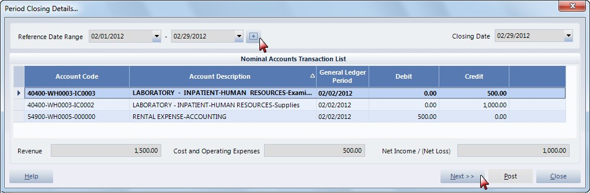

1. The closing of nominal accounts entries will now be listed. Review the entries then you can click the post button.

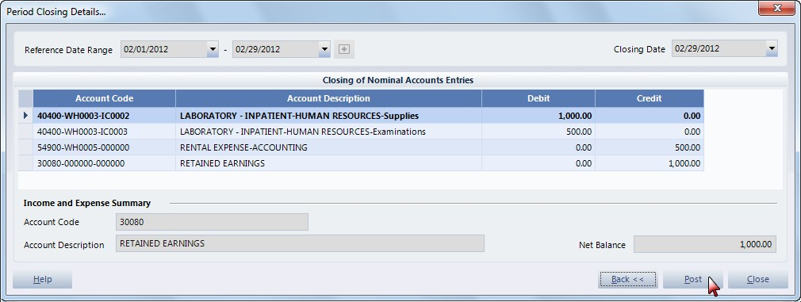

1. The confirm posting window will appear and will remind you the effects to the entries when they are posted. Click Ok when you are ready to post.
2. On the password validation entry will now appear, enter your user code and password the click accept.

#### Post-Closing Entries

The post closing entries process will post adjustments that were not included in the period closing. Heres the process: 1. Select the

#### Cancel Closing Entries

This process will cancel the latest period on the closing entries. Here’s a quick process on that.

1. Upon selecting the cancel closing entries on the sub components, the cancel closing entries window will appear wherein you can select the category from period closing or post-closing entries.

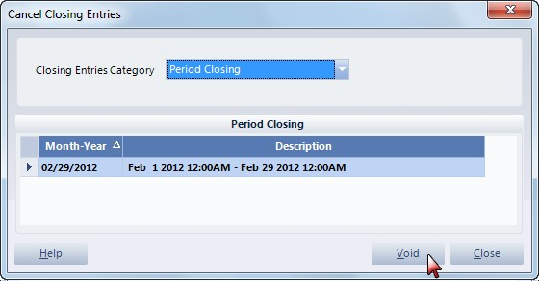

1. Click void button after selecting the entry to be cancelled.
2. To confirm the process, enter your user code and password on the password validation entry then click accept button.

#### General Ledger Reports

The general ledger reports will disaply all the entries in the general ledger on a specific date range. Here’s a print preview of the report:

